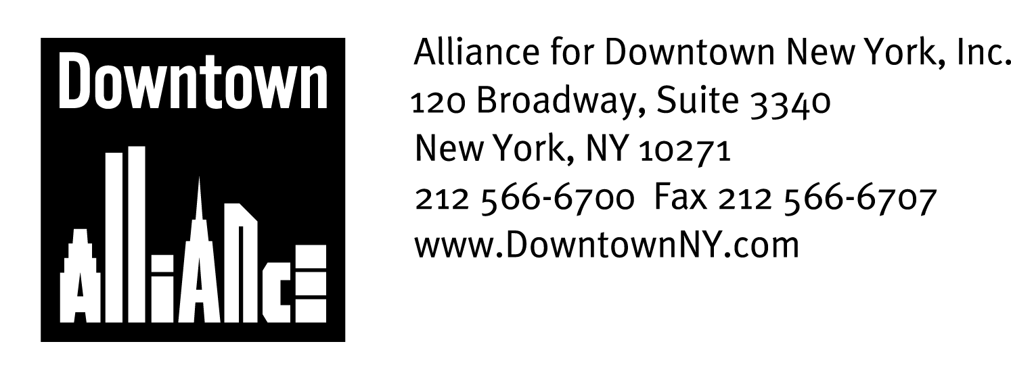

PRESS CONTACT: Downtown Alliance, Bruce Brodoff (212) 835-2770
Shea Communications, Inc., George Shea, Mark Faris (212) 627-5766

Downtown Alliance, Assembly Speaker Sheldon Silver
Launch “Bike Around Downtown” Bicycle Sharing Program

Log On, Sign Up and Explore Lower Manhattan By Bike – Completely Free!

New York, NY, June 13, 2008 — The Alliance for Downtown New York, Lower Manhattan’s Business Improvement District, is now offering workers, residents and visitors another great reason to work, live and play in Lower Manhattan. Beginning Friday, June 13, the Downtown Alliance, through its new Bike Around Downtown pilot program, is providing the public with bicycles for use throughout Lower Manhattan, completely free!

This exciting bike sharing program is funded through a grant from NY State Assembly Speaker Sheldon Silver.

Inspired by the international movement in green transportation and recreation and following programs in cities like Amsterdam, Paris, Lyon, Munich, Vienna, Stockholm, London, Barcelona, Helsinki, and now Washington, DC, the Downtown Alliance has contracted with bicycle rental and tour company “Bike and Roll,” to provide free bikes seven days a week through October 31. All biking enthusiasts, visitors, and local residents and workers who want a convenient way to travel around and explore the district need to do is pre-register for specific time periods at www.downtownny.com/bikearound and then pick up the bike at the Bike and Roll Kiosk at the South Street Seaport.

“The Downtown Alliance’s “Bike Around Downtown” program offers the public a free, fun and green way to travel around historic, fascinating and beautiful Lower Manhattan,” said Elizabeth H. Berger, President of the Downtown Alliance. “Lower Manhattan packs an astonishing array of attractions and destinations into its one square mile, and there’s no better way to see them than from a bicycle seat. From the Brooklyn Bridge to bike paths along the East River and Hudson River waterfronts to the winding streets of the Financial District, there’s great architecture, great restaurants, great shopping and history at every turn. I thank Speaker Silver for providing the funding for this program, and look forward to exploring the district with our colleagues and neighbors as well as Downtown visitors.”

“I’m proud to have partnered with the Downtown Alliance to provide children and adults who live, work and visit downtown with a great way to explore my Lower Manhattan community,” said Assembly Speaker Sheldon Silver. “This new program will ensure that all people, regardless of their financial means, can enjoy a leisurely ride around downtown and take in all that this historic community has to offer. I congratulate the Downtown Alliance on another great new program to help improve the quality of life for all in Lower Manhattan.”

- More -
Downtown Bike Sharing
Page 2

The Downtown Alliance’s bike sharing program runs from June 13 to October 31, 2008 at the Bike and Roll kiosk located at the South Street Seaport, in front of Pier 17.

Bikes can be reserved (on a first-come, first-served basis) for the following daily sessions at www.downtownny.com/bikearound:

Monday through Friday:

- 9 a.m. to 11 a.m.
- 11:30 a.m. to 2 p.m.
- 4 p.m. to 7 p.m.

Saturday and Sunday:

- 9 a.m. to 1.m.
- 2 p.m. to 6 p.m.

Adult and children’s bikes will be available for each time period. Helmets with be provided with every bike, and free tag-a-longs, wagons and baby seats are available.

The Downtown Alliance’s Bike Around Downtown program provides a great service to people who do not own bikes, workers who can’t bring their bikes to work, and anyone looking to do something fun, healthy and FREE in Lower Manhattan.

The weekday sessions are perfect for families, tourists and especially area employees; Jumping on a bike and exploring Downtown is a great way to refresh and recharge during lunchtime or unwind after work! The weekend sessions allow for more time to fully explore Lower Manhattan, including Governor’s Island, where Bike and Roll also has a kiosk.

“New York, as always, is leading the way in innovative public programs with Bike Around Downtown," said Madelyn Wils, Executive Vice President for Development at the New York City Economic Development Corporation. "We applaud State Assembly Speaker Sheldon Silver and the Alliance for Downtown New York for bringing this program to the City and making it easy for people to enjoy the East River bikeway, soon to be improved as part of the new East River Waterfront Park.”

Janell Vaughan, Senior General Manager at General Growth Properties said, "For GGP, serving the community is like riding a bike - it's something that's just part of our culture. Now with Bike N Roll, the Seaport offers a way for everyone to have fun and stay active and healthy. Summer is back at the Seaport - come on down and take a ride!"

The mission of the Alliance for Downtown New York is to be the principal organization that provides Lower Manhattan's historic financial district with a premier physical and economic environment, advocates for businesses and property owners and promotes the area as a world-class destination for companies, workers, residents and visitors. The Downtown Alliance manages the Downtown-Lower Manhattan Business Improvement District (BID), serving an area roughly from City Hall to the Battery, from the East River to West Street.

###

