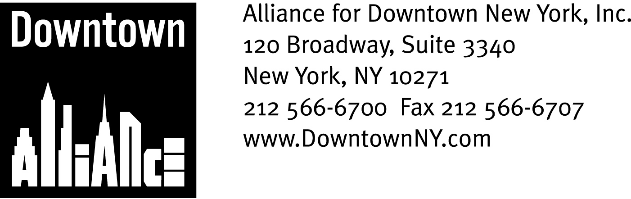

PRESS CONTACTS: Downtown Alliance, Bruce Brodoff (212) 835-2770
Shea Communications, George Shea, Mark Faris (212) 627-5766

FOR IMMEDIATE RELEASE

STATEMENT BY ALLIANCE FOR DOWNTOWN NEW YORK
CHAIRMAN ROBERT R. DOUGLASS ON J.P. MORGAN CHASE AGREEMENT

______________________________________________________________________

New York, NY, June 14, 2007 — J.P. Morgan Chase’s decision to take over development of Tower 5 at the World Trade Center site cements Lower Manhattan’s position as the financial capital of the world.

By agreeing to shift major operations and thousands of employees to a new skyscraper in Lower Manhattan, J.P. Morgan Chase has sent a clear message that New York City’s financial district is the premier location for banking and financial services companies. The addition of one more world class business center is a great sign for future commercial development downtown, and will help encourage other companies to maintain and expand their businesses in Lower Manhattan and attract new companies downtown.

The Downtown Alliance congratulates J.P. Morgan Chase, Governor Spitzer, The Port Authority of New York and New Jersey and Mayor Bloomberg on this historic agreement, and stands ready to assist J.P. Morgan Chase and all companies interested in or planning to locate or expand in Lower Manhattan.

The mission of the Alliance for Downtown New York is to be the principal organization that provides Lower Manhattan's historic financial district with a premier physical and economic environment, advocates for businesses and property owners and promotes the area as a world-class destination for companies, workers, residents and visitors. The Downtown Alliance manages the Downtown-Lower Manhattan Business Improvement District (BID), serving an area roughly from City Hall to the Battery, from the East River to West Street.

###

