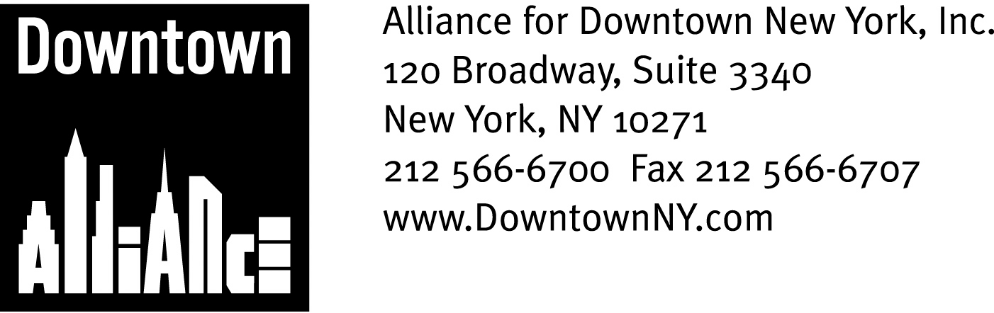

PRESS CONTACTS: Downtown Alliance, Bruce Brodoff (212) 835-2770
Shea Communications, George Shea, Mark Faris (212) 627-5766

FOR IMMEDIATE RELEASE

Alliance for Downtown New York Sponsoring Two Community Planting Events in October

Downtown Workers, Residents and Visitors Will Work Together
to Beautify Historic Bowling Green Park
______________________________________________________________________

New York, October 2, 2008 —

Get out your Green Thumbs!

October is community planting season in Lower Manhattan, as the Alliance for Downtown New York presents two community events that will help beautify Bowling Green Park and honor New York City’s rich history. The events are part of the Downtown Alliance’s "Going Green Downtown" initiative, which is dedicated to building a sustainable Lower Manhattan.

The first community event, a Geranium Giveaway at Bowling Green Park, will be held on Wednesday, October 8, 2008, from 12 PM until 2 PM.

More than 4,000 geraniums will be removed from the park in anticipation of a tulip bulb planting later in the month, and the Downtown Alliance and its sponsor are offering the community’s workers, residents and tourists the opportunity to dig up and keep their very own geraniums. Everyone is welcome to roll up their sleeves and get some dirt under their fingernails, but for those who want to watch, the expert horticulturalists from Phillips Nurseries will be on hand to dig out and pot the geraniums, which people can then take back to their home or office.

The Downtown Alliance will provide long-sleeve tee-shirts and tents and tables where participants can pot their geraniums, and tools will be provided by the Downtown Alliance and the NYC Parks and Recreation Department. In keeping with the event’s “green” theme, event sponsor BMW will also display a hydrogen-powered automobile at the park.

The Downtown Alliance’s Fall Community Planting Day at Bowling Green Park will take place on Sunday, October 19, 2008, from 10 AM through 1 PM. Phillips Nurseries will provide 1,500 orange Dutch tulip bulbs in honor of the 400th anniversary of establishment of New York City by the Dutch, which will be planted around the perimeter of the park. Community Planting Day participants will help plant the bulbs and ornamental kale around the perimeter of the park, as well as partake in mulching and raking activities.

-- More --

Community Planting Events
Page 2

The Downtown Alliance will provide a tent and tables to set up a plant potting and giveaway area for children, while Phillips Nurseries will provide extra giveaway plants, 400 pots and soil and bulb markers. The Downtown Alliance and the NYC Parks & Recreation will provide the tools, and the Downtown Alliance will also provide participants with long-sleeve tee-shirts and lunch.

“The Downtown Alliance’s upcoming community planting events build upon the success of our first annual Green Around Downtown Community Planting Day last May, during which more than 200 Downtown residents and employees – and a tourist or two – got their hands dirty helping to beautify Wall Street Park, got to know each other and were so enthusiastic about participating that they stayed long after we ran out of landscaping chores,” said Elizabeth H. Berger, president of the Downtown Alliance. “Our two new events will help build and beautify our community, celebrate New York City history and advance Lower Manhattan’s status as the country’s premier “green” community, and I thank all of the sponsors who helped make this possible.

The Downtown Alliance’s Community Planting Events are made possible BMW, Community Board 1, Glenwood Management, NYC Parks and Recreation and Swig Properties.

The Downtown Alliance has reached out to Lower Manhattan’s business and residential communities and educational and youth organizations and is expecting a large and enthusiastic turnout for both events.

Come down to Lower Manhattan and join the fun!

For more information about the Downtown Alliance’s “Going Green Downtown” initiative, visit www.downtownny.com/GoingGreen.

-- ### --

The mission of the Alliance for Downtown New York is to be the principal organization that provides Lower Manhattan's historic financial district with a premier physical and economic environment, advocates for businesses and property owners and promotes the area as a world-class destination for companies, workers, residents and visitors. The Downtown Alliance manages the Downtown-Lower Manhattan Business Improvement District (BID), serving an area roughly from City Hall to the Battery, from the East River to West Street.

