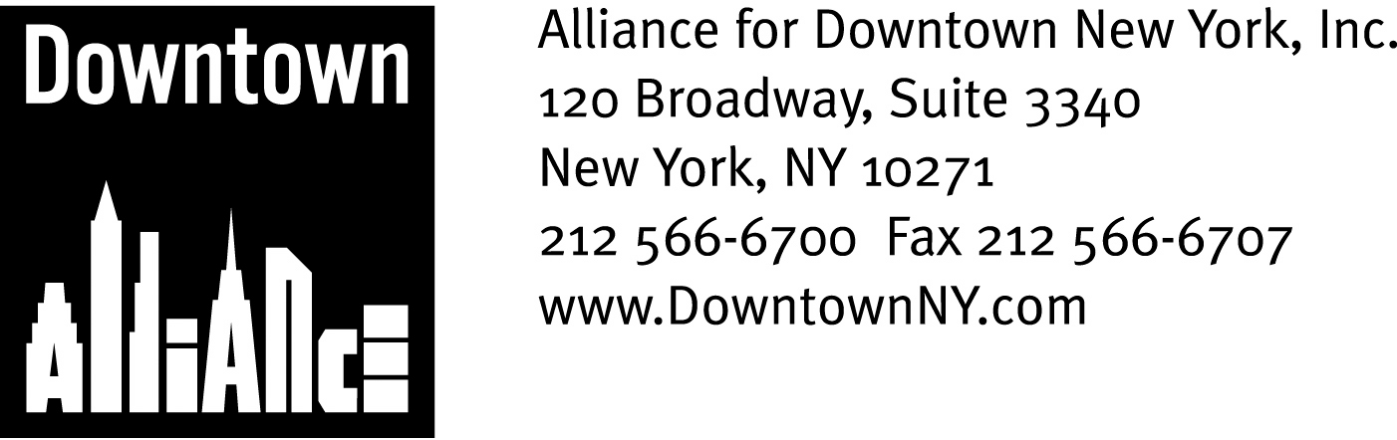

PRESS CONTACTS: Downtown Alliance, Bruce Brodoff (212) 835-2770
Shea Communications, George Shea, Mark Faris (212) 627-5766

FOR IMMEDIATE RELEASE

Alliance for Downtown New York endorses Mayor Bloomberg’s PlanYC and
Congestion Pricing initiative

Lauds Pricing As Effective Way To Fund Critical Mass Transportation Projects and Fight Urban Traffic; Urges Additional Actions to Improve Traffic Mobility in Lower Manhattan
______________________________________________________________________

New York, NY, June 27, 2007 —

The Alliance for Downtown New York, manager of the nation’s largest business improvement district, endorses Mayor Michael R. Bloomberg’s PLaNYC sustainability program, with particular support for the congestion pricing initiative.

“Mayor Bloomberg’s ambitious PlaNYC sustainability program once again demonstrates his commitment to securing the City’s future, including Lower Manhattan,” says Downtown Alliance Chairman Robert R, Douglass. “PlaNYC offers solid solutions to New York City’s pressing problems, and the congestion pricing initiative provides an effective way to finance important mass transit projects and address growing traffic concerns. The Alliance for Downtown New York looks forward to working with the Bloomberg Administration as these plans move forward.”

An excellent mass transit network is the lifeblood of the Lower Manhattan economy. Expanding the network and maintaining it in a state of good repair is critical to ensuring Lower Manhattan’s long-term viability as a world-class central business district, and revenues from congestion pricing could provide the opportunity to finance essential mass transit projects.
These projects include a direct rail link between Lower Manhattan and JFK Airport, which will provide enhanced access to the region’s labor market, and a full build-out of the Second Avenue Subway. Such system expansions will add capacity, convenience and new commuter options, which will help keep Lower Manhattan competitive in a global market place.
While congestion pricing is an important and welcome first step, other actions are needed to ensure improved traffic mobility in Lower Manhattan.

-- More --

PlaNYC/Congestion Pricing
Page 2

With narrower streets and fewer parking spaces than any other area in the city, Lower Manhattan faces congestion challenges distinct from those seen in Midtown. The congestion issues of Lower Manhattan will require focused efforts in additional areas, besides congestion pricing, including curb management, more careful supervision of construction sites, increased enforcement of traffic regulations, dedicated parking for commuter and tour buses, a committed approach to eliminate placard parking and official plate abuses, and implementation of MUNI meters for truck parking. Addressing these additional issues will enhance the effectiveness of congestion pricing in reducing traffic and pollution in Lower Manhattan.

“Lower Manhattan has the potential now to become a revitalized, state-of-the-art, 21st century live/work community – a model for urban centers around the world,” says Mr. Douglass. “Undoubtedly, congestion pricing and financing new transportation infrastructure will play a key role in achieving our goals.”

The mission of the Alliance for Downtown New York is to be the principal organization that provides Lower Manhattan's historic financial district with a premier physical and economic environment, advocates for businesses and property owners and promotes the area as a world-class destination for companies, workers, residents and visitors. The Downtown Alliance manages the Downtown-Lower Manhattan Business Improvement District (BID), serving an area roughly from City Hall to the Battery, from the East River to West Street. Detailed information on the Alliance for Downtown New York and Lower Manhattan can be found a www.downtownny.com

###

