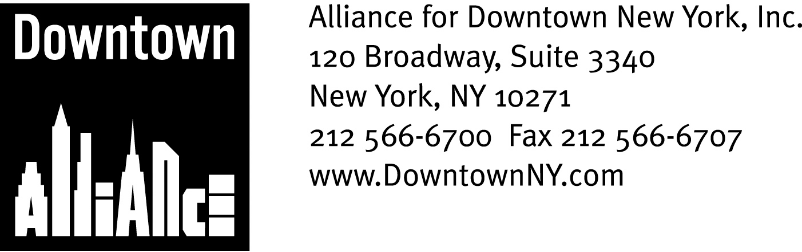

PRESS CONTACTS: Downtown Alliance, Bruce Brodoff (212-835-2770)
LMCC, Jessica Sagert (212) 219-9401 x114
Shea Communications, George Shea, Mark Faris (212) 627-5766

FOR IMMEDIATE RELEASE

DOWNTOWN ALLIANCE, LOWER MANHATTAN CULTURAL COUNCIL LAUNCH GROUNDBREAKING
PUBLIC ART Pilot Program

Redevelopment Activity Downtown Provides New “Canvases”
for Transformative Urban Art and Architecture

New York, NY, November 13, 2007 — The Alliance for Downtown New York and Lower Manhattan Cultural Council (LMCC) have collaborated to create and implement “Re:Construction,” a groundbreaking initiative that will turn Downtown New York construction zones into sites for unexpected and engaging public-art and architecture projects.

Coming at a time when Lower Manhattan is experiencing one of the largest public and private construction undertakings in the nation’s history, “Re:Construction” bridges the public sector and the creative community, generating excitement about the rebuilding process and improving the quality of life in Lower Manhattan by creating places of cultural attraction, curiosity and anticipation.

“We are very excited to be working with Lower Manhattan Cultural Council and some of the most creative people in New York City on this groundbreaking streetscape and wayfinding improvement project,” says Elizabeth H. Berger, President of the Downtown Alliance. ‘Re:Construction’ will help beautify our streets, provide directions to pedestrians, increase foot-traffic and economic activity downtown and alleviate some of the unavoidable impacts caused by these large construction projects.”

The art and architecture projects will be located at Fulton Street, Broadway and John Street — one of the busiest intersections in the fourth-largest business district in the nation. The projects will utilize construction infrastructure such as Jersey barriers, chain-link fencing and sidewalk shed scaffolding as canvases for art and architecture interventions. The intent is to engage thousands of passersby with surprising and functional designs, technological details that include solar-powered LEDs, and sculptural elements that literally use the city as their setting.

“This initiative builds upon the diversity and excellence of the cultural community in lower Manhattan,” said First Deputy Mayor Patricia E. Harris. “We applaud the efforts of Lower Manhattan Cultural Council and the Downtown Alliance, who share the Mayor’s enthusiasm and commitment to public art in unexpected places.”

-more-

Re:Construction
Page 2

For the first phase of “Re:Construction,” the Downtown Alliance and LMCC considered 120 potential projects submitted by artists and architects that responded to an open call for proposals. The organizations ultimately commissioned are GRO Architects PLLC (Richard Garber and Nicole Robertson principals); the artist Tattfoo Tan; and a collaborative of architects and new media designers that includes Carlos J. Gómez de Llarena, Carolina Cisneros and Mateo Pintó D'Lacoste.

(See Page Three of the press release for detailed information on each project.)

“LMCC has had a long history of making ‘art happen here’ in Lower Manhattan. ‘Re:Construction’ is a perfect synthesis of our work and the Downtown Alliance’s construction mitigation project, as it literally weaves site-specific art and architecture into the city’s fabric,” said Adam Kleinman, associate curator with the Lower Manhattan Cultural Council. “We think this initiative establishes a new benchmark for response of artists to their civic environment worldwide, and we look forward to showcasing New York’s artists and architects in public-art projects, and to reconstruct more sites in the future.”

In addition to galvanizing the Lower Manhattan community, The Downtown Alliance and LMCC’s “Re:Construction” art initiative has also generated excitement and support among many prominent New York City officials.
On Thursday, November 8, 2007, the Lower Manhattan Development Corporation awarded the Alliance for Downtown New York a $1.5 million Community Enhancement Fund grant for the project. The Downtown Alliance is one of 33 Lower Manhattan non-profit organizations to receive funding through this $37 million grant program, which helps fund projects that focus on health care, education, community services, recreation, and cultural enrichment and are an important investment in Lower Manhattan’s future.
“Lower Manhattan is a community in the midst of a dramatic transformation. A side effect of that happy circumstance is the inconvenience that construction places on workers and residents," said Avi Schick, Chairman of the Lower Manhattan Development Corporation. "We are pleased that the Downtown Alliance and the Lower Manhattan Cultural Council are launching this creative effort to ease the impacts of redevelopment.”

“Congratulations to the Downtown Alliance and the Lower Manhattan Cultural Council for creating a new and innovative way to beautify our downtown community, which we are working to hard to rebuild,“ said Assembly Speaker Sheldon Silver.

-more-

Re:Construction
Page 3

"We applaud the Downtown Alliance and the Lower Manhattan Cultural Council on their innovative arts program, "Re:Construction," says Lee Sander, Executive Director and Chief Executive Officer of the Metropolitan Transportation Authority. “The MTA is delighted to partner with them to mitigate the impact of construction caused by the rebuilding of Lower Manhattan."

"During this period of intense construction, I applaud the Downtown Alliance's creativity in turning necessary safety barriers into works of art with a unique New York style," said New York City Transportation Commissioner Janette Sadik-Khan. "I look forward to working with the Alliance on this innovative project."

New York City Council Member Alan Gerson said, "This is a great project. Art has a role in every aspect of Lower Manhattan redevelopment, and I am pleased to see the Downtown Alliance and the Lower Manhattan Cultural Council continue their great cultural collaborations under dynamic new leaders."

"Two of Community Board One’s priorities are bringing more arts activity to Lower Manhattan and mitigating the impacts from all the redevelopment work underway here,” says Community Board One Chairperson Julie Menin. “Re:Construction will address both of these at once by converting construction sites into venues for spirited and vibrant public art displays. Downtown residents and workers need innovative and creative projects like Re:Construction to help us meet the challenge to our quality of life that will be posed by the many construction projects that we face in coming years."

The three projects/site selected for the initial phase of “Re:Construction” are:

“Best Pedestrian Route” by GRO Architects PLLC
John Street east from Broadway intersection

Architecture firm GRO Architects, located in Lower Manhattan, will design and build a freestanding modular pre-fabricated structure to replace the conventional sidewalk shed scaffolding corridor adjacent to the MTA’s renovation project of the landmark Corbin Building. The undulating angles of the structure’s surface will feature informational supergraphics, and a dappled backlit filigree screen that will improve nighttime visibility and safety. The orange, blue, and white colors of the structure are culled from the city of New York’s flag.

“Concrete Jungle” by Tattfoo Tan
Broadway between John and Ann Street/Fulton Street Transit Center

New York artist Tattfoo Tan’s whimsical project puns on the common metaphor “concrete jungle” by morphing the banal orange safety stripes on jersey barriers into brilliantly colored stenciled zebra strips, adding an element of the natural wild to our urban maze.

-more-

Re:Construction
Page 4

“Fulton Fence” by Carlos J. Gómez de Llarena, Carolina Cisneros and Mateo Pintó D'Lacoste
Fulton Street Corridor, east of Broadway

This collaborative of Venezuelan architects and new-media designers blends the functional with the playful using re-purposed construction materials. Accents of orange-and yellow plastic construction meshes, industrial caution lights, customized op-art signage and the chain-link fencing that universally signify construction-in-progress will be collaged into a vibrant mural bounding the water main retrofitting on Fulton Street. These treatments will be affixed in segments following the 10-foot long section frames of chain-link fencing that currently encircle the construction site.

At the time of installation, the team will establish a basic pattern along the line of the fence that combines 30 or more of these segments. As these get reconfigured by the contractors due to on-going construction, newly recombined patterns will be created, displaying, in design, the very history of the construction.

The mission of the Alliance for Downtown New York is to be the principal organization that provides Lower Manhattan's historic financial district with a premier physical and economic environment, advocates for businesses and property owners and promotes the area as a world-class destination for companies, workers, residents and visitors. The Downtown Alliance manages the Downtown-Lower Manhattan Business Improvement District (BID), serving an area roughly from City Hall to the Battery, from the East River to West Street.

Lower Manhattan Cultural Council (LMCC) is the leading voice for arts and culture in downtown New York City, producing cultural events and promoting the arts through grants, services, advocacy, and cultural development programs. lmcc.net

###

