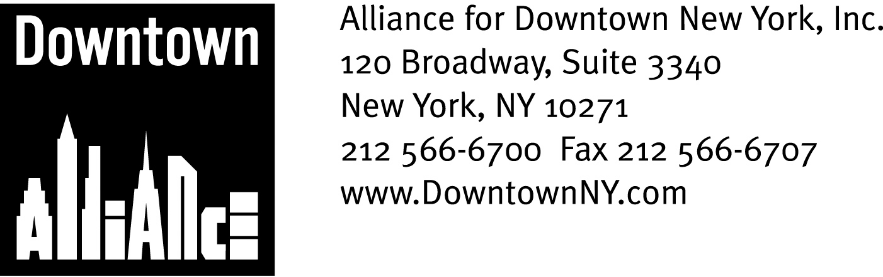

PRESS CONTACTS: Downtown Alliance, Bruce Brodoff (212-835-2770)
Shea Communications, George Shea, Mark Faris (212) 627-5766

FOR IMMEDIATE RELEASE

DOWNTOWN ALLIANCE UNVEILS NEW SERIES OF GROUNDBREAKING PUBLIC ART PROJECTS ON
DOWNTOWN CONSTRUCTION SITES

Redevelopment Activity Downtown Continues to Provide New “Canvasses”
for Transformative Urban Art and Architecture

New York, NY, September 22, 2008 —

The Alliance for Downtown New York is once again re-inventing public art with its groundbreaking Re:Construction initiative, which installs exciting, thought-provoking and scenic art projects at construction sites throughout Lower Manhattan.

Two new art projects – Houston Fence and Green Gate, Summer – have been installed at two downtown construction sites, bringing color, movement, nature vistas and “green” technology to Lower Manhattan streetscapes. The results are scenes that surprise and engage thousands of passerby as well as art lovers around the world.

Launched in November 2007 with the publicly and critically acclaimed Fulton Fence; Best Pedestrian Route and Concrete Jungle installations, Re:Construction bridges the public sector and the creative community, generates excitement about the rebuilding process and improves the quality of life in Lower Manhattan by creating places of cultural attraction, curiosity and anticipation. This new series of projects is sponsored by the American International Group, Inc. (AIG) and supported by the New York City Department of Design and Construction (DDC).

“We are delighted to work with AIG, DDC, and some remarkable artists on these groundbreaking streetscape projects,” says Elizabeth H. Berger, President of the Downtown Alliance. “These installations will beautify our streets, increase foot-traffic and economic activity downtown and alleviate some of the unavoidable impacts of construction projects. We are adding art to our civic improvement, economic development and construction mitigation tool kit, with innovative, inspiring and engaging results. Thanks to the Lower Manhattan development Corporation for helping us expand this idea throughout Lower Manhattan.”

The Houston Fence and Green Gate, Summer projects use construction infrastructure such as sidewalk shed scaffolding and construction fencing as canvasses for temporary art and architecture, engaging the public in their innovation and beauty. These installations celebrate functionality and literally use our city as their setting. (See attached PDF for full project details and photographs.)

-more-

Re:Construction
Page 2

“AIG is honored to join with the Alliance for Downtown New York and to be a part of the Re:Construction initiative, said Frederick J. Wunschel, president, AI Realty Corp. “AIG’s commitment to the community is demonstrated by this program which is designed to improve quality of life while rebuilding lower Manhattan. AIG looks forward to our continued cultural endeavors with the Downtown Alliance.”

"Reflecting the dynamism of New York City, we have a growing artistic community with a shortage of places to display their enormous creativity, as well as a significant number of public works projects which are renewing our vital infrastructure," said Department of Design and Construction Commissioner David J. Burney, FAIA. "A natural collaboration has emerged to give New Yorkers a new way to appreciate the talent of artists simply by walking -- carefully -- by our projects on Houston Street and Lower Manhattan."

The Downtown Alliance is now preparing for the next series of Re:Construction projects, a collaboration with independent curators, gallerists, and other creative specialists and artists. Over the next three years, the Downtown Alliance plans to incorporate artistic installations in up to 20 public and 60 private sites throughout the district and beyond.
Re:Construction is made possible by a $1.5 million Community Enhancement Fund grant awarded by the Lower Manhattan Development Corporation. The Downtown Alliance is one of 33 Lower Manhattan non-profit organizations to receive funding through this $37 million grant program, which helps fund projects that focus on health care, education, community services, recreation, and cultural enrichment and are an important investment in Lower Manhattan’s future.
“The Lower Manhattan community is obviously experiencing a dramatic transformation and redevelopment”, stated Avi Schick, Chairman of the Lower Manhattan Development Corporation. “We are pleased to work with the Downtown Alliance to beautify the streetscape and mitigate some of the effects of this necessary construction.”

The mission of the Alliance for Downtown New York is to be the principal organization that provides Lower Manhattan's historic financial district with a premier physical and economic environment, advocates for businesses and property owners and promotes the area as a world-class destination for companies, workers, residents and visitors. The Downtown Alliance manages the Downtown-Lower Manhattan Business Improvement District (BID), serving an area roughly from City Hall to the Battery, from the East River to West Street.

###

