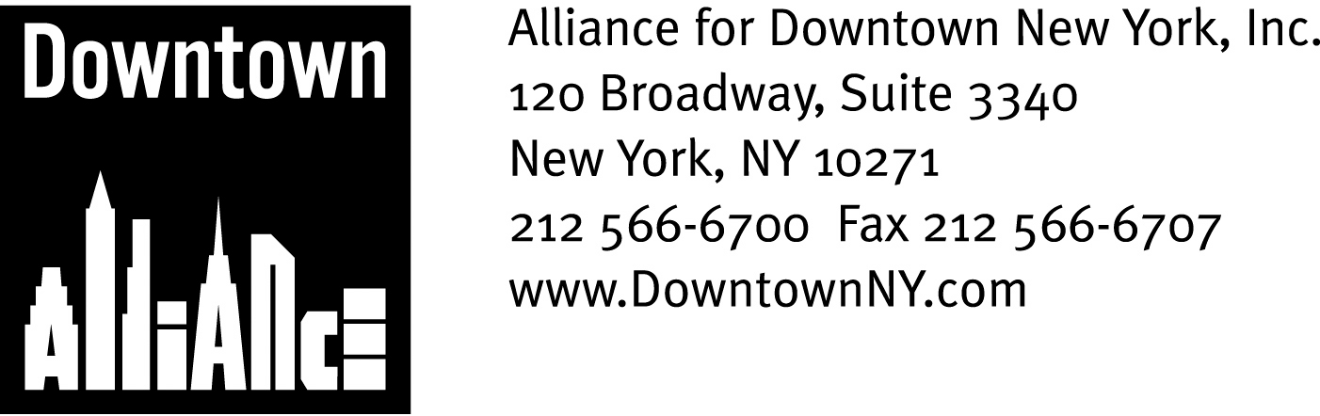

PRESS CONTACTS: Downtown Alliance, Bruce Brodoff 212-835-2770
Shea Communications, George Shea, Mark Faris (212) 627-5766

FOR IMMEDIATE RELEASE

ALLIANCE FOR DOWNTOWN NEW YORK ENDORSES STIMULUS FUNDING FOR THE FULTON TRANSIT CENTER

Put the Fulton Transit Center at the Top of the List of “Shovel-Ready” Priorities for
Federal Funding Under the American Recovery and Reinvestment Act of 2009, says President Elizabeth H. Berger; Transportation Hub is Key to Ensuring New York City’s
Competitiveness in the Global Marketplace

New York, April 28, 2009 —
Good afternoon.
I am Elizabeth H. Berger, president of the Alliance for Downtown New York, the Business Improvement District that serves Lower Manhattan’s 318,000 workers, 54,000 residents and six million annual tourists.
Thank you for the opportunity to tell you why the Fulton Transit Center is so important to the recovery and rebuilding of Lower Manhattan and the economic success of the entire metropolitan region.
Thank you Governor Paterson, Speaker Silver, Senators Schumer and Gillibrand, Mayor Bloomberg, Congressman Nadler, State Senator Squadron and the New York Metropolitan Transportation Council for putting the Fulton Transit Center at the top of the list of “shovel-ready” priorities under the American Recovery and Reinvestment Act of 2009. Let’s work together to keep it there.

Lower Manhattan’s past, present and future as the international capital of commerce depends on mass transit.

Hundreds of companies in a wide variety of industries have come to Lower Manhattan over the past several years, attracted by its value proposition, its growing, educated and affluent residential population situated among a strong commercial base, its critical mass of amenities, walk-to-work lifestyle and access to parks and other desirable open space.

And, our unmatched access to mass transportation. No part of New York City is more connected to the entire metropolitan area than Lower Manhattan: 14 subway lines and 12 stations, 8 local and 25 express bus routes, multiple ferry routes, a heliport and PATH train service to New Jersey. Total transit ridership in 2007 was 123 million people.

And here’s the thing: 90% of Lower Manhattan’s workers take mass transit or walk to work, and they are tired of waiting for transit amenities common in other global business capitals.

They are tired of construction chaos and street closures, a degraded pedestrian experience, vast public expenditures with too few visible signs of progress and being told to manage their expectations. They are tired of waiting for the Fulton Transit Center, as are Lower Manhattan’s commercial property owners and tenants, large companies and small businesses, residents and residential developers, hotels, schools and cultural institutions

The Fulton Transit Center will provide additional capacity, commuting options and shopping and dining opportunities for Lower Manhattan’s residents, tourists and workers and better connect Lower Manhattan to the regional work force. Ready-to-go, cost-effective, energy efficient and “green,” the Fulton Transit Center is what Lower Manhattan needs and what Lower Manhattan was promised, a vitally important project that will help ensure that Lower Manhattan and New York City remain a world financial capital and competitive in the global marketplace. And, it will create 4,000 construction-related jobs.

The train has left, but there is no station. Let’s build it. Let’s keep the shovel-ready Fulton Transit Center on the top of the list of stimulus package projects.

Thank you.

