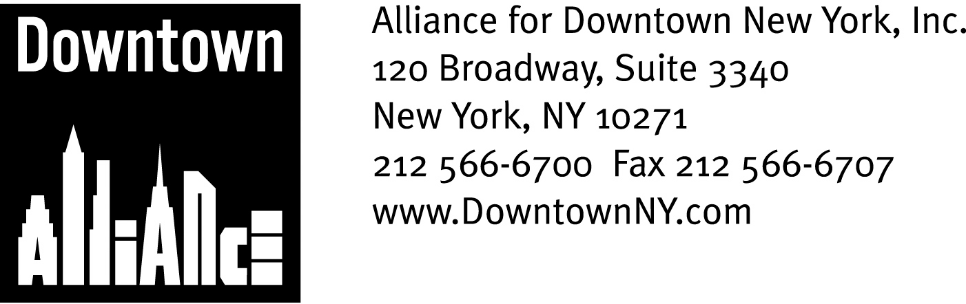

PRESS CONTACTS: Downtown Alliance, Bruce Brodoff 212-835-2770
Shea Communications, George Shea, Mark Faris (212) 627-5766

FOR IMMEDIATE RELEASE

Downtown Alliance Launches Green Initiative
to Help TRansform Lower Manhattan

‘Going Green Downtown’ Offers Current Data on Sustainability,
Energy Conservation Strategies

______________________________________________________________________

New York, NY, Nov. 30, 2007 — The Alliance for Downtown New York has published, “Going Green Downtown,” a brochure offering up-to-date information on sustainability and energy conservation strategies. The publication is part of the organization’s efforts to assist the transformation of Lower Manhattan into a greener neighborhood.

“Lower Manhattan has been at the forefront of many trends in New York,” said Elizabeth H. Berger, president of the Downtown Alliance. “Now, our community is leading the way once again with innovative efforts to go green. The Downtown Alliance is committed to helping property owners, businesses and residents get involved in creating a more sustainable and eco-friendly Lower Manhattan.”

“Going Green Downtown” outlines concrete ways for anyone to begin putting sustainability practices into effect. It shares the latest information on green regulations and energy efficiency that can improve the quality of life Downtown and enhance the submarket’s competitive edge. It also highlights the achievements of Lower Manhattan’s environmental leaders, and the efforts to introduce green innovation and technology.

As part of its sustainability initiative, the Downtown Alliance and the Downtown-Lower Manhattan Association sponsored a breakfast forum titled “Going Green Downtown.” The event, held in late November, explored green building policies and market trends impacting the future of Lower Manhattan.

The panel was moderated by James Cavanaugh, president & CEO of the Hugh L. Carey Battery Park City Authority and included Rohit Aggarwala, director of long-term planning and sustainability with the Mayor’s Office of Operations; Sally Wilson, global director of environmental strategy for CB Richard Ellis; and Elliot Zuckerman, director of building services for the New York Mercantile Exchange and CEO of Earth Management Solutions LLC.

-more-

In addition, the Downtown Alliance has posted its “Going Green Resource Guide” online. The online resource was designed to provide useful and current information on sustainability and efficiency. Since transforming Lower Manhattan must be a collaborative effort, the site also allows Downtown residents, workers and building owners to provide insights, experiences and concerns about achieving greater sustainability in Lower Manhattan.

For more information on “Going Green Downtown,” please visit the Downtown Alliance’s Web site at www.DowntownNY.com/goinggreen.

The mission of the Alliance for Downtown New York is to be the principal organization that provides Lower Manhattan's historic financial district with a premier physical and economic environment, advocates for businesses and property owners and promotes the area as a world-class destination for companies, workers, residents and visitors. The Downtown Alliance manages the Downtown-Lower Manhattan Business Improvement District (BID), serving an area roughly from City Hall to the Battery, from the East River to West Street.

###

