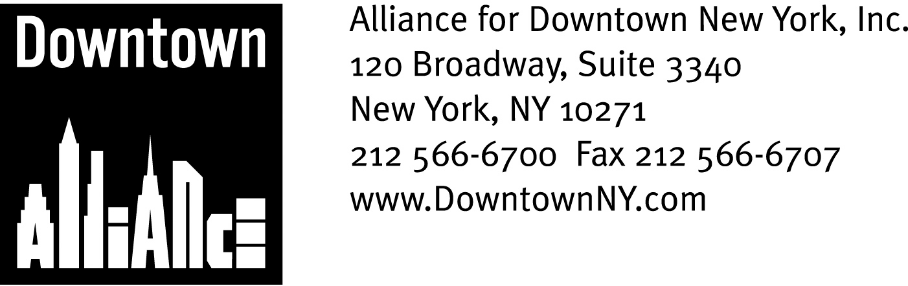

PRESS CONTACTS: Downtown Alliance, Bruce Brodoff (212) 835-2770
Shea Communications, George Shea, Mark Faris (212) 627-5766

Lower Manhattan Is Premier Place to Shop,
Celebrate This Holiday Season!

Upscale Retail, Dining District Offers Shoppers Affordable Luxury,
Quality at Every Price Point; Exciting Holiday Entertainment Options

NEW YORK, Oct. 10, 2008 — The growth and development of Lower Manhattan as an integrated business, residential and tourist center has made it a mecca for many of the world’s great retailers and restaurants. And now, with an amazing variety of shopping and dining opportunities for every budget, festive lighting and outdoor fun — including affordable ice skating at Seaport Ice, the brand-new outdoor rink at the South Street Seaport and New York City’s newest community tree-lighting ceremony at Zuccotti Park — Lower Manhattan is also a premier holiday destination for local, national and international shoppers!

“Lower Manhattan is one of the most dynamic and successful live-work communities in the world, as well as an upscale retail and dining district that offers workers, residents and visitors affordable luxury and quality at every price point, “ said Elizabeth H. Berger, president of the Alliance for Downtown New York. “Lower Manhattan is easy to get to via public transportation from anywhere in the metropolitan area and combines terrific shopping and dining opportunities with world-famous historic, architectural and cultural landmarks. With all of these options available in its very walkable one-square mile, it’s time for everyone to discover this secret: Lower Manhattan is the place to shop and celebrate the holiday season!”

Nearly 100 new stores and eateries have opened for business in Lower Manhattan since 2002, with luxury retailers and national chains leading the charge. High-end retailers like Tiffany & Co., Hermes, BMW, Hickey Freeman, Borders Books, Whole Foods, Tumi, Papyrus, Thomas Pink, Godiva Chocolate, Canali, Barnes & Noble, Bed, Bath and Beyond, Sephora, True Religion Jeans and La Maison du Chocolat now have stores in Lower Manhattan, joining world-famous retail destinations J&R Music World and Century 21 Department Store.

In addition to many nationally-known and luxury retailers, Lower Manhattan is also home to many long-time favorite and new mom-and-pop shops and independent retailers that accommodate the district’s wide range of worker and resident interests and incomes. William Barthman Jewelers has been selling the finest merchandise on Lower Broadway since 1884, and Modell’s Sporting Goods, Samuel’s Hats and historic Bowne and Company Stationers, which has been doing business in Lower Manhattan since 1775, all offer great prices on unique and fabulous gifts.

-more-
Lower Manhattan Holiday Shopping
Page 2

In addition, neighborhood newcomers Firefly Children’s Boutique, Denim and Knits and Andrea Katz Objects,a quirky, contemporary clothing and accessories line that features clothing as architectural objects for the body, all offer great deals on unique items for fashionistas of all ages and budgets.

Lower Manhattan retailers cater to shoppers of every budget, and many offer exceptional gifts for $100 or less, including Christopher Norman Chocolates, which handcrafts their renowned treats from its kitchen facility/retail store on New Street; Pylones, which offers eye-catching designs and innovative twists on everyday objects and gifts; Gamestop, which offers great prices on new and used videogame and entertainment software; and Edible Arrangements, a twist on the usual floral bouquet, which offers beautiful and delicious fruit bouquets for all occasions.

For the pets on your gift list, Petropolis on Washington Street offers affordable designer beds, designer pet carriers, a huge selection of pet toys and high-quality, all-natural treat baskets. For the avid golfer, The World of Golf offers “tour authentic” golf umbrellas, Clubhouse duffel bags, women’s backpacks and golf shoes. Cosmetics and fragrance retailer Sephora can beautify the holidays with its “Best of Sephora” Philosophy Gift set, while specialty paper shop Papyrus features stylish Regina Grigio picture frames as part of its ever-expanding array of unique gift products, greeting cards, tote bags and organizers, stationery, writing instruments, note cards and journals.

Lower Manhattan is also the place to celebrate the holidays with a fine dining experience, as many stylish and upscale restaurants have opened Downtown over the past few years. Lower Manhattan’s culinary scene, which was invented by the legendary steakhouse Delmonico’s 171 years ago, is thriving with a wide and exciting variety of restaurants that have opened over the past few years, including Roy’s New York, The Grill Room, Ketch, Acqua, Stella Maris, Nelson Blue, Trinity Bar and Grill, Cipriani, 2 Gold, Bobby Vans, Haru, Zen Palate, Battery Gardens, Le Pain Quotidien, Crumbs Bakeshop and Fresco to Go.

Stone Street, until a few years ago a derelict side street from the city’s colonial days, is now Lower Manhattan’s unique and world-famous restaurant row, home to such esteemed restaurants as Harry’s Café and Steakhouse, Brouwers, Financier Patisserie, Smorgas Chef, Ulysses Folk House and Stone Street Tavern.

Renowned chef Todd English recently opened “The Libertine,” a two-story restaurant designed to evoke a cozy yet sleek London clubhouse of the 1970’s in the Thompson Group’s new hotel, Gild Hall, on Gold Street, while another internationally renowned chef, Shaun Hergatt, will open SHO Shaun Hergatt, a lavishly conceived, 12,500 square foot restaurant and lounge located in the luxurious new Setai Condominium and Club to bring culinary excitement and a “South Beach vibe” to Broad Street.

With all of these great restaurants to choose from, you can even combine fine dining and shopping in one easy and pleasurable experience: Enjoy some delicious meals in Lower Manhattan, and then purchase gift certificates as great holiday gifts!

-more-

Lower Manhattan Holiday Shopping
Page 2

The Downtown Alliance has launched a new marketing initiative to highlight Lower Manhattan’s fantastic range of retail and dining possibilities and position the neighborhood as a premiere holiday destination.

For details regarding the Downtown Alliance’s holiday campaign as well as a comprehensive directory of Lower Manhattan retailers, restaurants and holiday events, visit www.downtownny.com

The mission of the Alliance for Downtown New York is to be the principal organization that provides Lower Manhattan's historic financial district with a premier physical and economic environment, advocates for businesses and property owners and promotes the area as a world-class destination for companies, workers, residents and visitors. The Downtown Alliance manages the Downtown-Lower Manhattan Business Improvement District (BID), serving an area roughly from City Hall to the Battery, from the East River to West Street.

###

