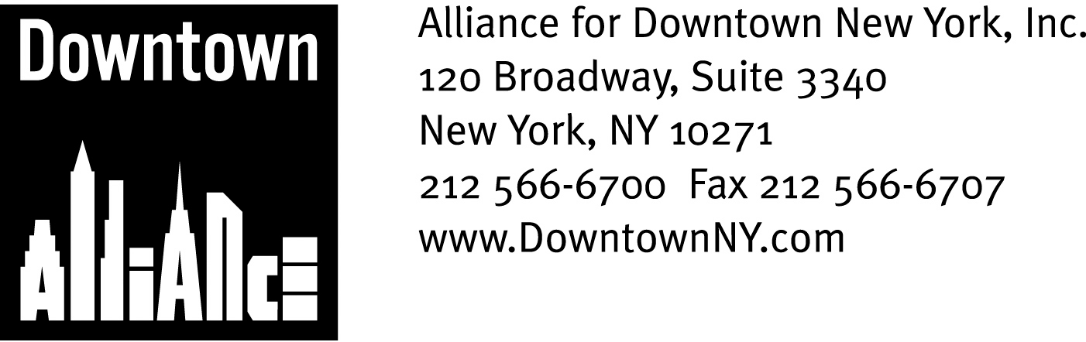

PRESS CONTACTS: Downtown Alliance, Bruce Brodoff (212) 835-2770
Shea Communications, George Shea, Mark Faris (212) 627-5766

Downtown Alliance To Launch
Holiday Marketing Campaign

Multi-year Effort Brands Lower Manhattan as Premiere Holiday Shopping Destination

NEW YORK, Oct. 24, 2008 — The Alliance for Downtown New York is set to launch a new marketing initiative to highlight Lower Manhattan’s diverse retail and dining offerings and position the neighborhood as a premiere holiday destination.

The Downtown Alliance’s multi-year holiday marketing campaign, the product of a roundtable with representatives from the Lower Manhattan retail community, will commence in mid-November and targets Downtown New York residents, workers and travelers as well as the rest of the city and the surrounding metropolitan area. The initiative promotes Lower Manhattan’s exciting roster of retailers and restaurants that offer affordable luxury and quality products at every price point.

“Lower Manhattan is one of the most dynamic and successful live-work communities in the world, as well as an upscale retail and dining district that offers workers, residents and visitors affordable luxury and quality at every price point, “ said Elizabeth H. Berger, president of the Alliance for Downtown New York. “Lower Manhattan is easy to get to via public transportation from anywhere in the metropolitan area and combines terrific shopping and dining opportunities with world-famous historic, architectural and cultural landmarks. With all of these options available in its very walkable one-square mile, it’s time for everyone to discover this secret: Lower Manhattan is the place to shop and celebrate the holiday season!”

Nearly 100 new stores and eateries have opened for business in Lower Manhattan since 2002, with luxury retailers and national chains leading the charge. High-end retailers like Tiffany & Co., Hermes, BMW, Hickey Freeman, Borders Books, Whole Foods, Tumi, Pylones, Thomas Pink, Godiva Chocolate, Staples, Canali, Barnes & Noble, Bed, Bath and Beyond, Sephora, True Religion Jeans and La Maison du Chocolat now have stores in Lower Manhattan. They join world-famous retail destinations J&R Music World and Century 21 Department Store, as well as many long-time favorite and new mom-and-pop shops and independent retailers that accommodate the district’s wide range of worker and resident interests and incomes.

The Downtown Alliance’s marketing plan includes a new brochure, “Downtown for the Holiday,” an updated Web site (www.downtownny.com/shop ) and e-blast promotions, mailers and print advertisements in a variety of publications including The New York Times, the New York Observer, New York magazine and Time Out New York. Advertising posters will be displayed at strategically selected bus shelters throughout Lower Manhattan and in all 13 PATH stations and train lines.
-more-
Downtown Alliance Holiday Shopping Campaign
Page 2

The Downtown Alliance will also link the promotion of its holiday shopping campaign with a variety of Lower Manhattan events, activities and venues, including the popular annual tree lighting ceremony at Zuccotti Park and Seaport Ice, the brand-new outdoor rink at the South Street Seaport.

One crucial element of the marketing campaign is creating a connection with present and prospective retail tenants, investors and developers to elevate the status of Lower Manhattan as a viable retail center. The Downtown Alliance is supplementing its strategy with a retail attraction component to encourage new tenancy and investment.

The tremendous growth of Lower Manhattan’s retail and dining sectors is directly related to the remarkable progress that the district has experienced over the past seven years. Some of the compelling facts and figures that have helped attract and retain retailers and restaurants since 2002 include:

- Lower Manhattan is the nation’s fourth-largest business district, with a daily population of approximately 318,000 “white-collar” workers. More than 200 firms in a wide variety of industries relocated to Lower Manhattan from midtown Manhattan and other parts of the metropolitan area since 2005.
- Approximately $550 million is spent Downtown each year by Lower Manhattan employees.
- Nearly 57,000 people now live in the area south of Chambers Street, more than double the pre-9/11 population.
- The current total disposable income of Lower Manhattan residents is $2.6 billion.
- Lower Manhattan’s households are mostly couples, many of whom have children or plan to have children soon.
- There were nearly 6 million visitors to Lower Manhattan in 2007

For a comprehensive directory of Lower Manhattan retailers, restaurants and holiday events, visit www.downtownny.com

The mission of the Alliance for Downtown New York is to be the principal organization that provides Lower Manhattan's historic financial district with a premier physical and economic environment, advocates for businesses and property owners and promotes the area as a world-class destination for companies, workers, residents and visitors. The Downtown Alliance manages the Downtown-Lower Manhattan Business Improvement District (BID), serving an area roughly from City Hall to the Battery, from the East River to West Street.
###

