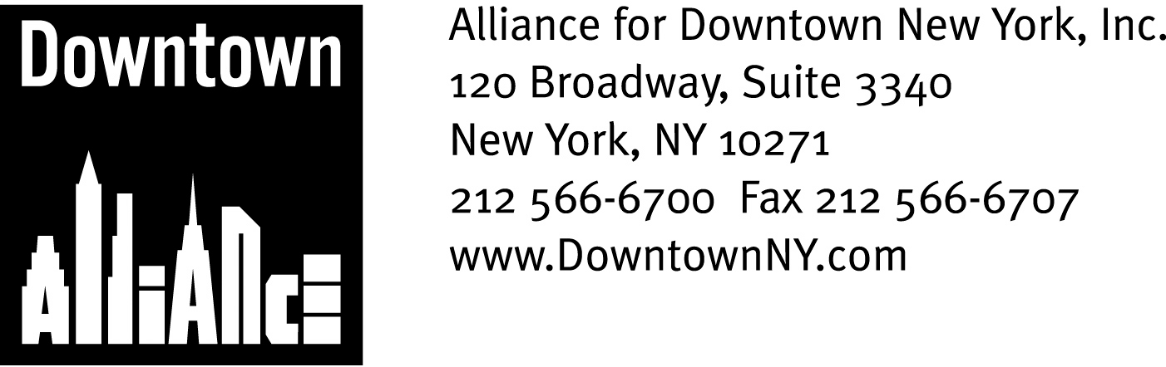

PRESS CONTACTS: Downtown Alliance, Bruce Brodoff (212) 835-2770
Shea Communications, George Shea, Mark Faris (212) 627-5766

FOR IMMEDIATE RELEASE

Alliance for Downtown New York urges
u.s. department of Homeland security to
restore Funding for New York City
______________________________________________________________________

New York, NY, June 15, 2006 – The Alliance for Downtown New York strongly urges the United States Department of Homeland Security to fully restore the Urban Area Security Initiative (UASI) funds earmarked for New York City for Fiscal Year 2006.

Lower Manhattan, which is the fourth-largest business district in the United States, has experienced a major resurgence over the past five years. As the manager of Lower Manhattan’s Business Improvement District, the Downtown Alliance has worked closely with the public and private sector to once again make this historic area New York City’s best place to work, live, visit and locate a business.

Lower Manhattan’s recovery from the tragic events of September 11, 2001 is a tribute to both the resilient spirit of New Yorkers and to the crucial role Lower Manhattan plays in the security and prosperity of our country.

Many of the major companies that drive the American economy either have their headquarters or a major presence in Lower Manhattan. Many smaller entrepreneurial companies are joining these major corporations in Lower Manhattan, helping diversify the economy and provide continued economic growth.

Concurrent to this influx of companies is a boom in Lower Manhattan’s residential population, which has increased 60% between 2000 and March 2006. Approximately 37,000 people now live in Lower Manhattan (up from 23,000 pre-9/11), and this figure is on track to reach 42,000 people by the end of 2007 and 50,000 by the end of the decade.

The transformation of Lower Manhattan into a fully-realized business and residential community will be greatly enhanced over the next few years, as the redevelopment of the World Trade Center site reaches fruition and even more businesses, residents and cultural and educational institutions call Lower Manhattan home. This transformation helps maintain the strength and stability of New York City and must be protected by the full faith and resources of the United States government.

- More -

Homeland Security Funds
Page 2

Lower Manhattan’s importance to New York City and the nation cannot be overstated, and cutting the amount of UASI money New York City receives from $207 million to $124 million – a full 40% reduction – greatly impacts the ability of the New York City Police Department to plan for and implement appropriate security measures.

A more vulnerable Lower Manhattan means a more vulnerable nation, and the Downtown Alliance respectfully requests that the United States Department of Homeland Security provides the fair funding that the City of New York needs to help businesses and the public remain secure and help keep Lower Manhattan the financial capital of the world.

The mission of the Alliance for Downtown New York is to be the principal organization that provides Lower Manhattan's historic financial district with a premier physical and economic environment, advocates for businesses and property owners and promotes the area as a world-class destination for companies, workers, residents and visitors. The Downtown Alliance manages the Downtown-Lower Manhattan Business Improvement District (BID), serving an area roughly from City Hall to the Battery, from the East River to West Street.

###

