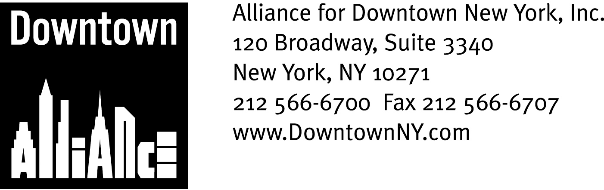

PRESS CONTACTS: Downtown Alliance, Bruce Brodoff (212) 835-2770
Shea Communications, George Shea, Mark Faris (212) 627-5766

FOR IMMEDIATE RELEASE

Downtown Alliance Lauds Extension of Tax Abatement

Measure Extends $2.50 PSF Tax Incentive Through 2010
______________________________________________________________________

New York, NY, April 2, 2007 — The Alliance for Downtown New York is pleased to announce that the New York State Legislature has approved a three-year extension of the $2.50 per-square-foot real estate tax abatement available through the Commercial Revitalization Program.

The tax incentive, which was set to expire on March 31, 2007, is part of the Commercial Revitalization Plan enacted in 1995 to encourage businesses to occupy office and retail space in Lower Manhattan. The measure reduces real estate taxes in pre-1975 buildings in Lower Manhattan for five years by up to $2.50 per square foot.

“We are thankful for the efforts of the New York State Legislature and the Governor to ensure the continuation of this important incentive program, and are particularly grateful for the leadership of Assembly Speaker Sheldon Silver, who so ably represents our district”, says Eric Deutsch, President of the Alliance For Downtown New York. “We are also extremely appreciative of the City, whose support was critical for the timely approval of this extension.”

The tax abatement program requires building owners to pass this savings directly through to tenants via reduced rents. Applicants are required to make certain minimum expenditures to improve the eligible premises. Leases must commence by March 31, 2010, and tenants have 180 days from commencement to apply for the tax abatement. The abatement zone for Lower Manhattan is bounded by Murray Street and Frankfort Street on the north, South Street on the east, Battery Place on the south and West Street on the west.

The Real Estate Tax Abate Program is one of several business incentive programs that helped attract hundreds of new companies and thousands of workers Downtown. These programs also helped restore the number of businesses currently located in Lower Manhattan to its pre-September 11, 2001 level. Two other vitally important incentive programs that were major catalysts for development in Lower Manhattan, the Lower Manhattan Energy Program and the Industrial and Commercial Incentive Program, are set to expire at the end of June.

Information on all Lower Manhattan incentives is available at: www.downtownny.com/incentives

The mission of the Alliance for Downtown New York is to be the principal organization that provides Lower Manhattan's historic financial district with a premier physical and economic environment, advocates for businesses and property owners and promotes the area as a world-class destination for companies, workers, residents and visitors. The Downtown Alliance manages the Downtown-Lower Manhattan Business Improvement District (BID), serving an area roughly from City Hall to the Battery, from the East River to West Street.
###

