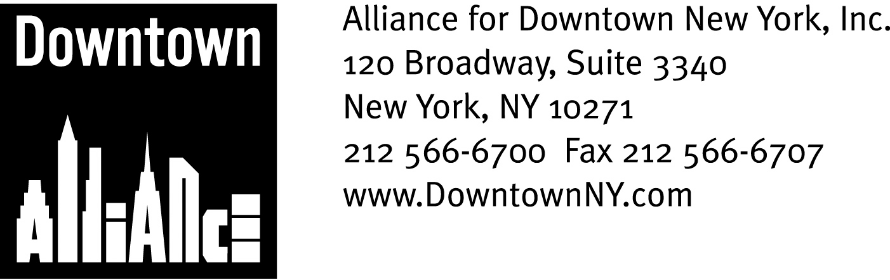

PRESS CONTACTS: Downtown Alliance, Bruce Brodoff 212-835-2770
Shea Communications, George Shea, Mark Faris (212) 627-5766

FOR IMMEDIATE RELEASE

STATEMENT FROM THE ALLIANCE FOR DOWNTOWN NEW YORK ON THE FEDERAL STIMULUS PACKAGE AND NEEDED INFRASTRUCTURE INVESTMENT IN LOWER MANHATTAN

Now Is The Time To Secure Federal Funds And Invest in New York City’s Infrastructure, says President Elizabeth H. Berger; Lower Manhattan Projects – Particularly the
Fulton Transit Center – are Key to Ensuring New York City’s
Competitiveness in the Global Marketplace

New York, February 9, 2009 —
Good afternoon Chairman White.
I am Elizabeth H. Berger, president of the Alliance for Downtown New York.
On behalf of Lower Manhattan’s 318,000 workers, 54,000 residents and millions of annual tourists, I thank you for convening this very important hearing.
The proposed Federal Economic Stimulus Package can have a major, transforming effect on New York City. I am happy to see that our elected leadership recognizes that we now have a tremendous opportunity to secure funds for critically important infrastructure projects in New York City – particularly in Lower Manhattan.
As we have learned from previous crises, investment in major infrastructure projects is a proven engine of economic recovery. Many of New York City’s greatest achievements – including Rockefeller Center, the Empire State Building, Battery Park City and the World Trade Center – were created during periods of great economic and political uncertainty and were instrumental in stabilizing and revitalizing our economy.
In fact, more than 50 years ago, during a time of economic uncertainty much like the one we are in now, Downtown-Lower Manhattan Association founder and Downtown Alliance sponsor David Rockefeller harnessed the power of the public and private sectors to complete numerous large-scale projects. These very projects helped transform Lower Manhattan into the global model of a 21st century, 24/7 live/work community it is today.

Lower Manhattan’s remarkable revitalization has greatly contributed to New York City’s standing as a world business capital. It is within this context that we must continue to fund and build infrastructure projects in Lower Manhattan.

While there are many worthy infrastructure projects under consideration all over New York State, no issue is more important to the region, state and city than transportation.

As mass transportation is the lifeblood of Lower Manhattan, no project is more important to the region, state and city than the Fulton Transit Center, an above-ground, architecturally significant transit hub with significant retail that the MTA promised Lower Manhattan shortly after 9/11.

No part of New York City is more connected to the entire metropolitan area than Lower Manhattan: 14 subway lines and 12 stations, 8 local and 25 express bus routes, multiple ferry routes, a heliport and PATH train service to New Jersey. Total transit ridership in 2007 was 123 million people. And here’s the thing: 90% of Lower Manhattan’s workers take mass transit or walk to work, and they, and the firms which employ them, are tired of waiting for transit amenities common in other global business capitals. They are tired of construction chaos and street closures, a degraded pedestrian experience, vast public expenditures with too few visible signs of progress and being told to manage their expectations.

The Fulton Transit Center will provide additional capacity, commuting options and shopping and dining opportunities for Lower Manhattan’s residents, tourists and workers and better connect Lower Manhattan to the regional work force. It is what Lower Manhattan needs and what Lower Manhattan was promised, a vitally important project that will help ensure that Lower Manhattan and New York City remain a world financial capital and competitive in the global marketplace.

The time has come for the MTA to fulfill its promise to Lower Manhattan and build the Fulton Transit Center.

I’m very happy to note that the MTA has recently committed to the Fulton Street project hundreds of millions of dollars it expects to receive in federal funding, but we need to make sure that this money is forthcoming. It is imperative that our elected officials fight as hard as they can to secure funding for desperately-needed infrastructure projects like the Fulton Transit Center.

As history has taught us, now is the time to defy expectations, not manage them. We must not lose sight of the forest for the trees and put aside important investments during this time of economic uncertainty. Once again, we must take the long view on the economy and take bold but proven steps to secure our future.

Thank you.

