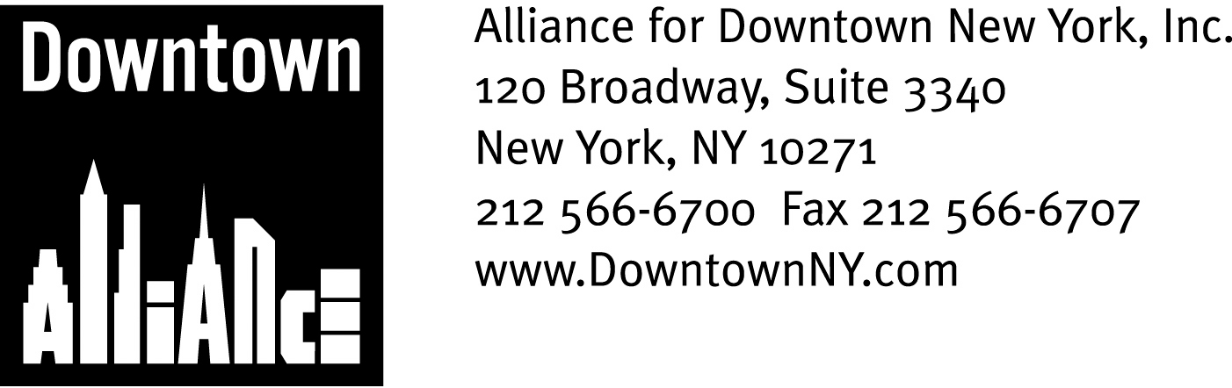

PRESS CONTACTS: Downtown Alliance, Bruce Brodoff (212) 835-2770
Shea Communications, George Shea, Mark Faris (212) 627-5766

ALLIANCE FOR DOWNTOWN NEW YORK SPONSORS
FIRST- EVER LOWER MANHATTAN “JELLY”

Free, Informal, One-Day Co-Working Event Will Bring Together
Independent and Home Workers for Networking, Collaborating and Socializing
______________________________________________________________________

New York, NY, May 7, 2009 —

The Alliance for Downtown New York, in collaboration with the co-working facility New Work City, is bringing the world-wide “Jelly” phenomenon to Lower Manhattan by sponsoring a free, informal, one day co-working event for freelancers, independent workers, those who work from home and anyone working on a project or business idea.

Begun in 2006, Jelly was born as a means for the freelancing community to come together to work, brainstorm, share and learn. Since then, the Jelly movement has spread to more than 20 cities around the world.

The Downtown Alliance’s Lower Manhattan “Jelly” will take place on Friday, May 15th at the World Financial Center Winter Garden (220 Vesey Street; Lobby Level), from 9:00 a.m. to 5:00 p.m.

Everyone is welcome to participate in this free event, which will be hosted by Brookfield Properties. Tables and chairs and WiFi will be provided, and an event facilitator will help make the personal introductions – Just bring a laptop, other work materials and a good attitude, and be open to whatever the day may bring!
“Jelly meetings allow freelancers, self-employed and home workers to network and work together,” said Elizabeth H. Berger, president of the Downtown Alliance. “Lower Manhattan’s diversified economy and growing residential population consists of many up-and-coming companies, service providers and entrepreneurs, and this event encourages interesting people to meet, bounce ideas off one another, collaborate and socialize. It’s a great way to make new contacts and make new things happen!”

-- More --

Jelly Meeting
Page 2

The May 15th Jelly meeting is just one way the Downtown Alliance is advancing Lower Manhattan’s position as a premier 24/7, live/work community. In addition to a wide array of business, residential and tourist services, the Downtown Alliance also offers free, 24/7 Internet access at nine wireless hotspots throughout Lower Manhattan (City Hall Park, Plaza at 7 World Trade Center, Winter Garden, South Street Seaport, Bowling Green Park, 60 Wall Street Atrium, British Memorial Garden, Stone Street and the Vietnam Veterans Plaza – visit www.downtownny.com/discover/wifi for full details.)

More than 30,000 users – workers, residents, students and tourists – logged on to the Lower Manhattan Wireless Network in 2008, turning these public spaces into areas conducive to productivity and creativity. The WiFi service at the Winter Garden will be an integral and invaluable component to the overall Jelly experience on May 15th, providing participants with free and fast access to the Internet.

Seating is limited at the Winter Garden Jelly, so participants are encouraged to register in advance. For more information on the Downtown Alliance’s programs and to register for the free May 15th Jelly, please visit www.downtownny.com

For more information about Jelly, visit http://workatjelly.com/.
###

The mission of the Alliance for Downtown New York is to be the principal organization that provides Lower Manhattan's historic financial district with a premier physical and economic environment, advocates for businesses and property owners and promotes the area as a world-class destination for companies, workers, residents and visitors. The Downtown Alliance manages the Downtown-Lower Manhattan Business Improvement District (BID), serving an area roughly from City Hall to the Battery, from the East River to West Street.

