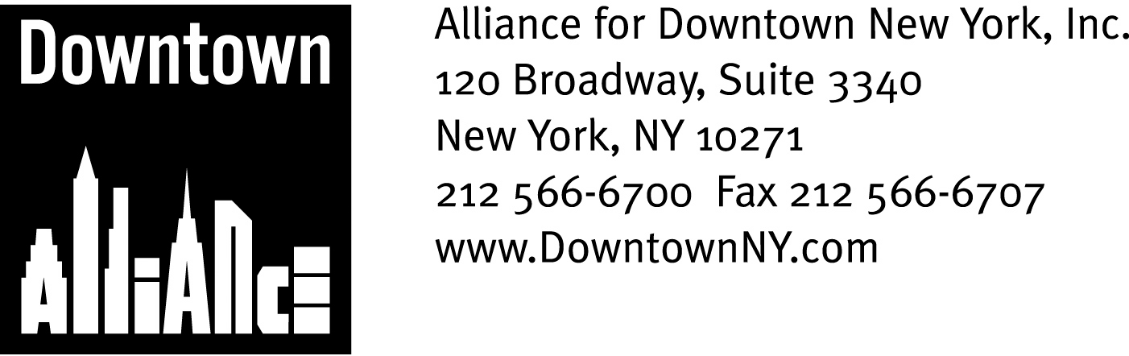

PRESS CONTACTS: Downtown Alliance, Bruce Brodoff 212-835-2770
Shea Communications, George Shea, Mark Faris (212) 627-5766

FOR IMMEDIATE RELEASE

STATEMENT OF
THE ALLIANCE FOR DOWNTOWN NEW YORK
ON THE FULTON STREET TRANSIT CENTER PROJECT

The Metropolitan Transit Authority Must Fulfill Its Commitment to Lower Manhattan, says President Elizabeth H. Berger; Fulton Transit Center Must Serve the Needs of the Revitalized Business and Residential District

New York, February 11, 2008 —
Good evening Chairwoman Menin, Vice Chairwoman McVay Hughes, Committee Members, elected officials, neighbors and friends.
I am Liz Berger, President of the Alliance for Downtown New York, and I am here tonight because the Lower Manhattan business community was stunned, as you were, to learn that the future of the Fulton Transit Center is in doubt. We want the Fulton Transit Center built as originally designed and we want it built now.

As a former member of this board and a 26-year resident of Lower Manhattan, I know I don’t need to tell you that the intersection of Fulton Street and Broadway is the crossroads of Lower Manhattan and the center of our future. All of us – commercial property owners and tenants, large companies and small businesses, residents and residential developers, schools and cultural institutions -- have been waiting for the Fulton Transit Center which the MTA promised our community, and I don’t need to tell you that the Fulton Transit Center they promised us – an iconic station with 20,000 square feet of above-ground retail and below-ground connections to 11 subway lines -- is essential to Lower Manhattan. We can’t settle for less and we can’t wait any longer.

The major commercial buildings around what was supposed to be the new Fulton Transit Center can’t wait. Billions of dollars have been spent on new construction and renovation on the promise of a 21st century Fulton Transit Center.

Commercial tenants can’t wait. They’ve come downtown or stayed downtown on the promise of a new Fulton Transit Center.

Local residents who’ve been up all night as the site of the new Fulton Transit Center was demolished and endured construction chaos for almost 2 years can’t wait.
-- More --
Fulton Street Statement
Page 2

And, neither can more than a hundred small businesses evicted from the site on the promise of a new Fulton Transit Center, either out of business or trying to make a living elsewhere in the community. They can’t wait either.

And they can’t settle for less. Lower Manhattan is being reborn – with first class office space, a growing residential population and top-shelf retail, hotels and other amenities. We are emerging from the rebuilding process an even better and more competitive business district, a global model of a live/work community. But we have to keep it going. We have to make sure that prospective new businesses, retailers and residents maintain confidence in our future. The Fulton Transit Center as originally designed is essential because, with over 90% of Downtown’s employees commuting by mass transit or on foot, Downtown’s future depends on a top quality passenger experience.

This is why the 311,000 people who work here and more than 50,000 people who live here need the original design for the Fulton Street Transit Center, which the MTA, LMDC and other State and government agencies presented to us over and over again: architect Nicholas Grimshaw’s distinctive above-ground structure with more than 20,000 square feet of retail. This is what is needed, this is what we were promised and this is what we deserve. Remember, the project has already been modified due to cost concerns. Further reductions or the elimination of the Fulton Street Transit Center building are simply not acceptable.

In closing, a few words of history. The attacks of September 11 not only destroyed the World Trade Center, they devastated the Downtown business district and shattered the confidence of our entire community. More than 14 million square feet of Class A office space were lost. Downtown slipped to fourth place in rankings of U.S. business districts. Some companies left, many new ones were scared to come Downtown and some predicted that Lower Manhattan’s best days were permanently behind us.

But those of us who love this community never wavered in our determination – and, having sat on this very committee, I know that is especially true of all of you. In the public debates following 9/11, everyone agreed that big improvements to our major transportation facilities, including the World Trade Center PATH station and the antiquated Broadway-Fulton subway complex, were essential to rebuild Downtown. Just as important, it was critical to send a message to the world that both the private and public sectors were ready to step up and make strategic, long-term and smart investments in Lower Manhattan.

The Lower Manhattan business community, led by the Downtown Alliance, strongly supported the urgent request for funds to reinvent and rebuild Downtown’s two key transit hubs because we knew it was right.

Lower Manhattan’s employees and residents have lived with several years of transit-related construction, because we knew it was right.

-- More --

Fulton Street Statement
Page 3

After spending $819 million in public funds and six years of our time, it is not right – in fact, it is short-sighted, unfair and unjust – for the MTA to announce that there is not enough money available to complete the above-grade portion of the project and that the below-ground portion will not be done until at least 2010. I remind you that the whole Transit Center was supposed to open this year!

The Downtown Alliance urges the MTA to honor its commitment to Lower Manhattan. We applaud and join with Speaker Silver, who has already called on the MTA to find the money to build the Transit Center as originally designed, and do it now. But, if this is not possible, we urge the MTA to reconsider the possibility of a public-private partnership using the development rights over the now-cleared site at Broadway and Fulton Street. This is a responsible option that should be analyzed carefully. As we have seen elsewhere in New York City and around the world, an appropriate project including some private development could result in a world-class above-grade station facility, with dynamic retail, and generate significant revenue for the MTA.

Above all, the MTA must act now and determine what is necessary to get this project back on track.

Thank you.

-- ### --

The mission of the Alliance for Downtown New York is to be the principal organization that provides Lower Manhattan's historic financial district with a premier physical and economic environment, advocates for businesses and property owners and promotes the area as a world-class destination for companies, workers, residents and visitors. The Downtown Alliance manages the Downtown-Lower Manhattan Business Improvement District (BID), serving an area roughly from City Hall to the Battery, from the East River to West Street.

