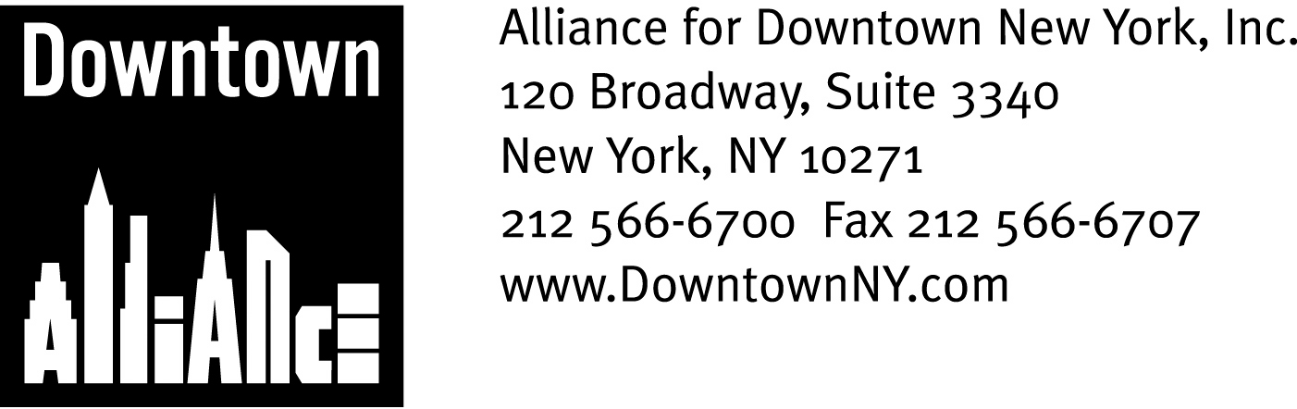

PRESS CONTACTS: Downtown Alliance, Bruce Brodoff 212-835-2770
Shea Communications, George Shea, Mark Faris (212) 627-5766

FOR IMMEDIATE RELEASE

STATEMENT OF
THE ALLIANCE FOR DOWNTOWN NEW YORK
ON PROPOSED MTA SERVICE CUTS AND
CHANGES AFFECTING LOWER MANHATTAN

The Metropolitan Transit Authority’s Proposed Changes Will Undermine Lower Manhattan’s Economic Viability, says President Elizabeth H. Berger; MTA Must Continue to Serve the Needs of the Revitalized Business and Residential District
and Build the Fulton Transit Center

New York, January 15, 2009 —

On behalf of the Lower Manhattan business and residential communities, the Alliance for Downtown New York urges the Metropolitan Transit Authority to rethink its proposed reductions in Lower Manhattan subway and bus service. These cuts are short-sighted and threaten Downtown’s long-term economic health.

Transportation is the key to Lower Manhattan’s past, present and future. Fourteen subway lines, 33 local and express bus routes, multiple ferries, bikeways, a heliport and the PATH -- no part of New York City is more connected to the entire metropolitan area, and our future as the international capital of finance and commerce – now redefining what it means to be a central business district with a thriving residential and tourist population – depends on it.

Lower Manhattan’s one square mile is home to 318,000 employees and close to 57,000 residents, and last year hosted 6 million tourists. In 2007, subway ridership was 86 million, total ridership was 123 million and average daily ridership was 338,000. This mass transit network is the lifeblood of Lower Manhattan; In fact, many of the district’s larger employers say that access to mass transit is the reason they started, stayed or relocated in Lower Manhattan, and it’s a huge plus for residents and visitors as well.

Add the current focus on sustainability to the mix, and maintaining and expanding Lower Manhattan’s mass transit network should be one of the MTA’s top priorities.

However, Lower Manhattan’s mass transit network is now under siege, hostage to pennywise but pound foolish gap closing exercises.

-- More --

MTA Service Cuts
Page 2

In an area where 90% of employees either take public transportation or walk to work, where unprecedented levels of private and public construction have made our historically congested streets less passable and endless delays in critical transportation infrastructure projects have profoundly degraded the passenger experience, the MTA has proposed dire cuts in bus and subway service.

These cuts could reverse a decade of commercial, residential and tourism growth by eliminating some underground and surface lines and reducing the quantity and quality of service on others. It doesn’t make sense, especially considering that average daily subway ridership increased at every single Lower Manhattan station over the last year.

The Bowling Green station saw an increase of 11%, and through September 2008, ridership at Fulton St./Broadway Nassau station – which serves ELEVEN subway lines, including the overcrowded A, E and 4, 5 lines and is the 10th busiest station in New York City with 19 million riders in 2007 – experienced a 7% increase over the same period in 2007. The Brooklyn Bridge/City Hall station, which serves New York City’s civic center, also saw similar increases in ridership over the past year.

The MTA’s plans will ensure that even more people have to wait for multiple trains to pass before they board, and when they do, the trains will be even more crowded than they are now. As bad as this situation will be, the proposed service changes will create far more troubling ramifications for Lower Manhattan’s future. Consider just a few MTA proposals and their consequences:

- No M6 buses down Broadway to major retailers like J&R Music World and Century 21 or international tourist destinations like the National Museum of the American Indian and the Sports Museum of America.

- No W service at all, further complicating the commute of commercial tenants on Water Street heading to Western Queens.

- No late night N service south of Chambers, isolating this growing residential part of our community.

- No more M15 buses to City Hall. Ever.

- Weekend changes on bus lines and night changes on subway lines that will adversely impact Lower Manhattan’s residents and tourists, the two populations that have experienced the strongest growth since September 11th.

- Suspending the M22 during the weekends, which will eliminate a crucial connection between Battery Park City (and its major tourist attractions), City Hall, the Financial District and Chinatown.

-- More --

MTA Cuts
Page 3

In light of the tremendous progress Lower Manhattan has made over the past few years and the challenges that lie ahead, now is the worst possible time to start cutting service from Lower Manhattan.

The fundamental amenity of a robust mass transit system can continue to fuel Lower Manhattan’s development, but only if we vigilantly protect and expand it.
No transit project will benefit Lower Manhattan more than the eagerly awaited Fulton Transit Center, the above-ground, architecturally distinctive subway hub with retail which has the universal support of Lower Manhattan business, elected officials and community leaders. This post-9/11 project was supposed to open in December 2007, untangling underground connections, linking east to west, attracting commercial tenants and delivering the kind of retail and related amenities available in every other major transit hub.
Downtown needs the Fulton Transit Center, and we need it now. This cost-effective and energy-efficient project will create 4,000 construction-related jobs and is ready to go. Hundreds of millions of public dollars have already been spent on the below-grade aspects of the project; when will work begin on the above-grade portion, so essential to Lower Manhattan’s commercial, residential and tourist populations?

Governor Paterson and Mayor Bloomberg recently requested billions of dollars in federal stimulus aid package proposed by President-Elect Obama for State and City transportation projects. The Fulton Transit Center should be at the top of any list: shovel-ready, “green” and a linch-pin of the future of America’s iconic live/work community, Lower Manhattan.

Despite our nation’s current economic troubles, Downtown is alive and well, growing and changing in fascinating and important ways. We must continue to make Lower Manhattan more attractive, more accessible, more sustainable and better equipped to service its growing business and residential communities and the millions of people who visit its attractions every year. Doing so is imperative to maintaining investor confidence in our district.

Now is the time to defy expectations, not manage them. Many of New York City’s greatest achievements – Rockefeller Center, the Empire State Building, Battery Park City and the World Trade Center – were begun in tough times.

We urge the MTA to not lose sight of the forest for the trees by imposing crippling cuts and delays on the transportation network that defines and supports Lower Manhattan.

-- ### --

