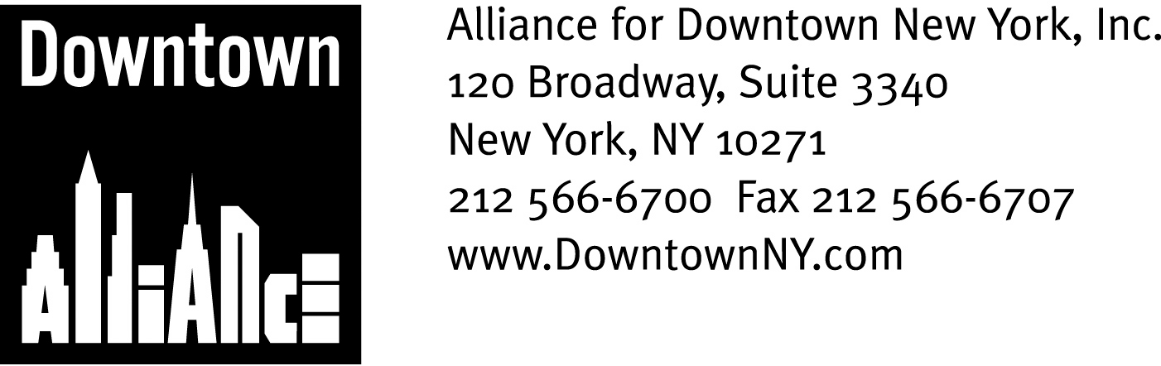

PRESS CONTACTS: Downtown Alliance, Bruce Brodoff 212-835-2770
Shea Communications, George Shea, Mark Faris (212) 627-5766

FOR IMMEDIATE RELEASE

STATEMENT BY ROBERT R. DOUGLASS, CHAIRMAN OF
THE ALLIANCE FOR DOWNTOWN NEW YORK, ON REPORTS
THAT MERRILL LYNCH MAY RELOCATE HEADQUARTERS

New York, Oct. 25, 2007 — While the reports that Merrill Lynch is seriously considering relocating its headquarters from Lower Manhattan — the business district where it was founded and has flourished for the past 93 years — to Midtown Manhattan are disappointing, I am hopeful that further consideration will persuade top management that keeping its headquarters in Lower Manhattan is the most economically prudent and forward-thinking choice, and the one that is in the best interest of the company, its shareholders and its employees.

Utilizing the many financial incentives available to the company if they choose to locate in the World Trade Center site or another site Downtown — including a PILOT deal that reduces real estate taxes, low cost power, and waiver of sales tax on the building, and the entire tenant fit-out — will save Merrill Lynch $600 million, while constructing a new headquarters in Midtown Manhattan could cost in excess of $600 million more than constructing a new one in Lower Manhattan. These two factors alone bring the additional cost of moving to Midtown to more than $1B, a figure that is hard to justify.

Economics aside, a revitalized Lower Manhattan is the logical home for Merrill Lynch in the decades to come. Lower Manhattan is now home to one of the strongest commercial real estate markets in the nation and is a magnet for luxury retailers and up-scale residential and hotel projects. Plans for the World Trade Center site have been finalized and construction has begun in earnest on the 9/11 Memorial, bringing the promise of millions of square feet of state-of-the-art office and retail space to fruition.

Goldman Sachs’ rapid construction of its new Lower Manhattan headquarters and JP Morgan Chase’s commitment to take over development of Tower 5 at the World Trade Center site is further evidence that New York's Financial District is the premier location for banking and financial services companies, as well as the premier location for Merrill Lynch’s new headquarters.

It is my hope that Merrill Lynch’s top management and board of directors will take all these factors into consideration and wisely elect to keep its headquarters Downtown.

-more-

The mission of the Alliance for Downtown New York is to be the principal organization that provides Lower Manhattan's historic financial district with a premier physical and economic environment, advocates for businesses and property owners and promotes the area as a world-class destination for companies, workers, residents and visitors. The Downtown Alliance manages the Downtown-Lower Manhattan Business Improvement District (BID), serving an area roughly from City Hall to the Battery, from the East River to West Street.

