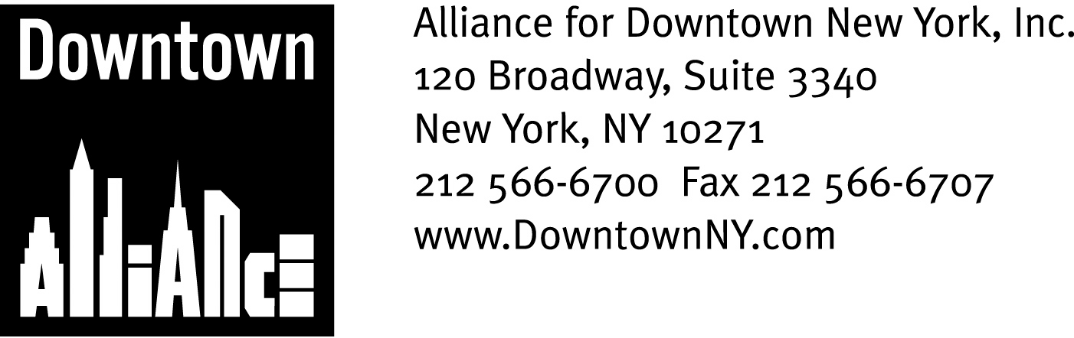

PRESS CONTACTS: Downtown Alliance, Bruce Brodoff 212-835-2770
Shea Communications, George Shea, Mark Faris (212) 627-5766

FOR IMMEDIATE RELEASE

New york giants FINALLY To be honored
on Lower Manhattan’s ‘Canyon of heroes’

Alliance for Downtown New York to Add Football Heroes to “Walk of Fame”
______________________________________________________________________

New York, NY, February 4, 2008 — In a fitting, and long-in-coming, tribute to the mighty New York Giants, the Alliance for Downtown New York will memorialize the team’s historic Super Bowl Victory and ticker-tape parade with a permanent commemorative plaque on Lower Manhattan’s “Canyon of Heroes.”

For more than 100 years, some of history’s most legendary individuals and sports teams have been honored with that most thrilling and quintessential New York celebration: the ticker-tape parade up Broadway’s Canyon of Heroes, which begins at the Battery and ends at City Hall.

In 2003, the Downtown Alliance launched New York’s version of the “Hollywood Walk of Fame” to commemorate the Canyon of Heroes with a series of black granite strips set into the sidewalks of Broadway every 25 feet along this storied route. These strips identify and celebrate the historic parades and the monumental achievements and importance of every ticker-tape honoree, an exclusive and fascinating fraternity that includes pioneers of air and space travel, soldiers, sailors and sea captains, heads-of-state, politicians, firemen, journalists, athletes and even a virtuoso pianist.

The plaque dedicated to the New York Giants, which is expected to be unveiled shortly on Broadway between Park Place and Barclay, will join the 202 plaques that currently grace lower Broadway. In addition to celebrating the football team’s accomplishments, this plaque will represent qualities and determination that have significant meaning to the Lower Manhattan community.

“Just like Lower Manhattan, the New York Giants overcame an underdog status and achieved the greatness some people believed impossible just a short time ago,” said Elizabeth H. Berger, president of the Alliance for Downtown New York. “The Downtown Alliance will proudly add a plaque dedicated to the New York Giants on the Canyon of Heroes so the team can take its permanent and rightful place among the legendary New York sports teams and historic individuals that have thrilled and inspired us all.”

-more-

Canyon of Heroes
Page 2

The Canyon of Heroes plaques are part of the Downtown Alliance’s Streetscape Program, which redesigned and updated the overall look of Downtown's streets according to a streetscape plan that received an award from the City's Art Commission for its uniqueness and elegance. The plan involved a variety of improvements, including reconstruction of all the sidewalks and curbs along lower Broadway, installation of new trash baskets, a user-friendly way finding and street sign system and handsome new light poles and street furniture.

The Alliance for Downtown New York, in a joint effort with the New York City Municipal Archives Department of Records and Information Services, produced a definitive brochure about New York City’s ticker-tape parades. Broadway: Canyon of Heroes Map and Guide is a fascinating, detailed look at the history of and stories behind the parades. The map of lower Broadway provides the exact locations for each plaque and has helped countless New Yorkers and visitors walk this path and relive the experience of these legendary events.

Either alone or coupled with a more comprehensive exploration of Lower Manhattan’s attractions and historic sites (the Alliance for Downtown New York offers free 90-minute walking tours of the Financial District every Thursday and Saturday at noon), a visit to New York’s Canyon of Heroes brings history alive in a most unique and immediate way.

Information on the Alliance for Downtown New York’s Broadway: Canyon of Heroes Map and Guide and walking tours of the Financial District can be found at www.downtownny.com

The mission of the Alliance for Downtown New York is to be the principal organization that provides Lower Manhattan's historic financial district with a premier physical and economic environment, advocates for businesses and property owners and promotes the area as a world-class destination for companies, workers, residents and visitors. The Downtown Alliance manages the Downtown-Lower Manhattan Business Improvement District (BID), serving an area roughly from City Hall to the Battery, from the East River to West Street.

###

