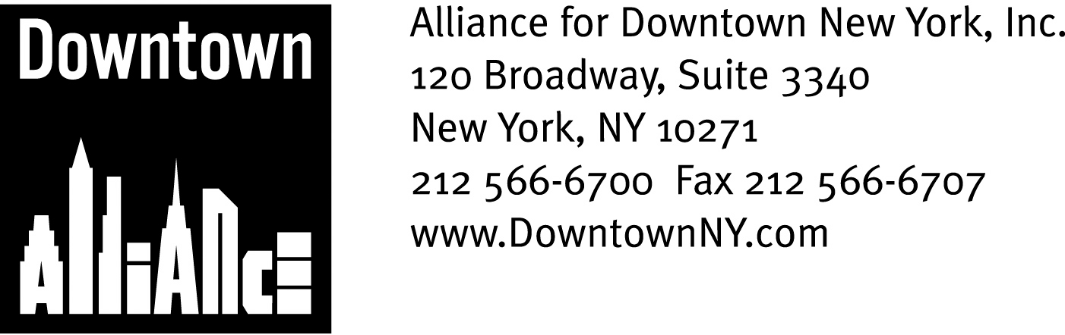

PRESS CONTACTS: Downtown Alliance, Bruce Brodoff 212-835-2770
Shea Communications, George Shea, Mark Faris (212) 627-5766

FOR IMMEDIATE RELEASE
October 2, 2008

STATEMENT ON THE FUTURE OF THE WORLD TRADE CENTER SITE, ALLIANCE FOR DOWNTOWN NEW YORK, ELIZABETH BERGER, PRESIDENT:

“Today’s Port Authority’s report is a welcome new roadmap for rebuilding the World Trade Center site. Executive Director Chris Ward and his team have taken a direct and practical approach and, after several months of analysis, have proposed what they believe is an achievable timetable, starting with the Memorial but including many key project elements.

Now more than ever, it is essential that this timetable be maintained. Lower Manhattan has proved time and again that if necessity is the mother of invention, adversity is the father. Rebuilding the World Trade Center site must advance Lower Manhattan as a global model for a 21st century central business district, a bustling and open commercial center with superior transportation, retail and cultural amenities. Lower Manhattan deserves and requires no less.

“Getting it done right on this timetable will require leadership from both the public and private sectors. Today is a new beginning, and we urge Governors Paterson and Corzine, Mayor Bloomberg, Chris Ward and the Port Authority’s bi-state leadership to stay committed, relentless and accountable until the project is fully realized.”

The mission of the Alliance for Downtown New York is to be the principal organization that provides Lower Manhattan's historic financial district with a premier physical and economic environment, advocates for businesses and property owners and promotes the area as a world-class destination for companies, workers, residents and visitors. The Downtown Alliance manages the Downtown-Lower Manhattan Business Improvement District (BID), serving an area roughly from City Hall to the Battery, from the East River to West Street.

###

