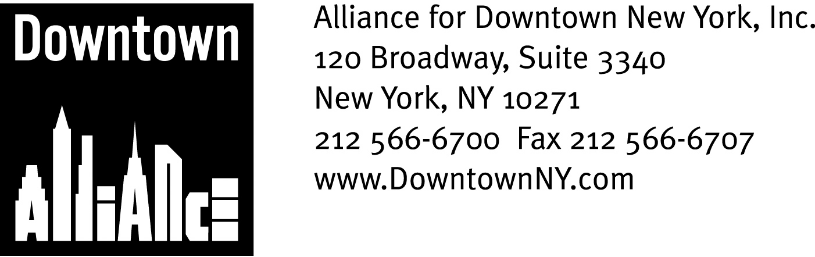

PRESS CONTACTS: Downtown Alliance, Bruce Brodoff (212) 835-2770
Shea Communications, George Shea, Mark Faris (212) 627-5766

FOR IMMEDIATE RELEASE

LOWER MANHATTAN Sidewalks Rated
“100% Acceptably Clean” by New York City Mayor’s Office of Operations

Alliance for Downtown New York’s Sanitation Operations Supplement City Services and Help Maintain A Clean and Attractive Environment in Lower Manhattan
______________________________________________________________________

New York, NY, August 24, 2007 —

The Alliance for Downtown New York is proud to announce that Lower Manhattan’s sidewalks have achieved a “100% Acceptably Clean” rating in the current New York City “Scorecard” issued by the New York City Mayor’s Office of Operations. “Scorecard’ is a 32-year-old independent visual inspection program managed by the Office of Operations that employs raters who go out monthly, unannounced, to visually examine and rate the cleanliness of New York City streets and sidewalks.

The recent street cleanliness Scorecard also found Lower Manhattan’s streets to be 97.9 % “acceptably clean, and New York City streets to be at a record-breaking high, with 94.3 % of streets rated "acceptably clean" for Fiscal Year 2007.

These street cleanliness scores are testament to the efforts of the New York City Sanitation Department as well as the supplemental sanitation services that business improvement organizations like the Alliance for Downtown New York provide to their districts.

“The Alliance for Downtown New York takes great pride in its continuous and concentrated efforts to make Downtown the cleanest, safest and brightest community in Manhattan,” says William Bernstein, Acting President of the Downtown Alliance. “The Downtown Alliance spends nearly $3.5 million per year – more than 20% of its annual budget – on sanitation and maintenance activities, and remains dedicated to improving the quality of life in Lower Manhattan and contributing to the overall cleanliness of New York City.”

The Downtown Alliance’s sanitation department was the first department to begin work when the organization was created in 1995. The department consists of six managers and 51 contract employees who work seven days a week helping clean and maintain Lower Manhattan’s streetscape.

-continued-

Lower Manhattan Sanitation
Page 2

In 1998 The Downtown Alliance’s first accomplishments replaced old city-issued litter baskets with 600 custom designed stainless steel litter baskets. The Downtown Alliance’s sanitation workers service these litter baskets several times a day, bagging and securing the trash in Downtown Alliance-supplied trash bags and setting these bags on the curb for easy pick-up by the New York City Department of Sanitation. The Downtown Alliance processed an estimated 450 tons of trash in the second quarter of 2007 and an estimated 850 tons so far this year.

This constant servicing of the litter baskets prevents the baskets from overflowing and greatly reduces the amount of litter in the district. Preparing the trash for pick-up also reduces the amount of time New York City sanitation workers spend removing trash in Lower Manhattan and helps maintain traffic flow on City streets.

The Alliance for Downtown New York’s sanitation department helps keep the sidewalks clean by “power swashing” them during the overnight hours with two machines that utilize hot water pressurized to 3,500 pounds per square inch. A list of “trouble spots” is regularly provided to the New York City Sanitation Department’s enforcement unit, which inspects these areas once a week and issues summonses when necessary.

Lower Manhattan’s remarkable resurgence over the past few years has created a new set of challenges, including a surge of construction projects, an influx of new residents, workers and tourists, several new parks and green spaces and concentrated pedestrian traffic, that adds to the litter and debris removal volume and keeps the Downtown Alliance’s sanitation department on its toes.

“Lower Manhattan’s dynamic environment can create adverse conditions that demand dedicated effort and creative solutions to remedy, “ says Joseph J. Timpone, the Downtown Alliance’s Vice President of Operations and a 31-year veteran of the New York City Department of Sanitation who retired in 1995 as the Department’s Director of the Bureau of Cleaning and Collection. “Our sanitation department works with the City and other involved stakeholders and constantly adjusts its personnel and resources to respond to various site-specific issues and ensure that all areas of our district meet the Downtown Alliance’s – and the City of New York’s – high standard for cleanliness.”

During the winter, the Downtown Alliance’s sanitation department also clears snow and ice from priority areas including subway entrances, bus stops, cross walks and public spaces, using a variety of plows, snow blowers, salt spreaders and good, old-fashioned physical labor.

Other duties include providing sanitation services for a wide variety of public and private events, working with the New York City Department of Environmental Protection to report and clear clogged sewers, and maintaining a “zero-tolerance” policy towards graffiti and illegal postings.

The mission of the Alliance for Downtown New York is to be the principal organization that provides Lower Manhattan's historic financial district with a premier physical and economic environment, advocates for businesses and property owners and promotes the area as a world-class destination for companies, workers, residents and visitors. The Downtown Alliance manages the Downtown-Lower Manhattan Business Improvement District (BID), serving an area roughly from City Hall to the Battery, from the East River to West Street.
###

