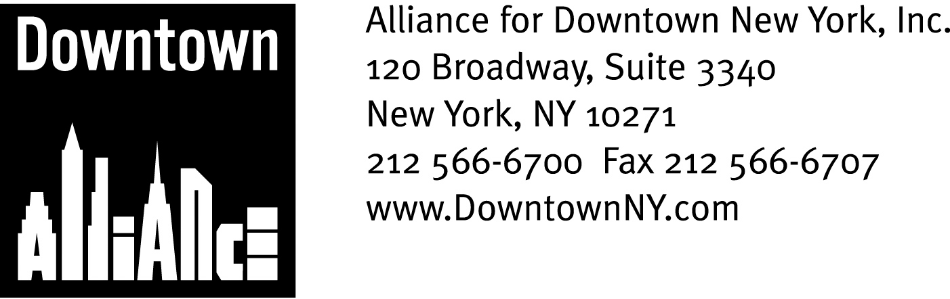

PRESS CONTACTS: Downtown Alliance, Bruce Brodoff 212-835-2770
Shea Communications, George Shea, Mark Faris (212) 627-5766

FOR IMMEDIATE RELEASE

STATEMENT OF
THE ALLIANCE FOR DOWNTOWN NEW YORK
ON THE GENERAL GROWTH PROPERTIES PLAN FOR THE SOUTH STREET SEAPORT
General Growth’s Plan Is Good For Downtown, says President Elizabeth H. Berger; the Vibrant Mix of Hotel, Retail and Open Space, and Proposed Amenities, Creates New and Much Needed Opportunities for Lower Manhattan’s Businesses, Residents and Tourists
New York, September 15, 2008 —
Good afternoon, Chairman Nelson, Chairman Gerson, and members of the Committees on Waterfronts and Lower Manhattan Development.
I am Liz Berger, President of the Alliance for Downtown New York, which manages the Lower Manhattan Business Improvement District.

I am here today to support the General Growth plan to make the South Street Seaport all that it can be: an architecturally distinctive, retail and hospitality magnet that will open up this part of New York City’s fabled waterfront to the business community, residents and tourists alike.

Lower Manhattan is where New York City began. The waterfront played a critical part in our city’s development, and today, almost 400 years after Henryk Hudson sailed into the harbor, it continues to be a place where people want to work, live and play. But for too long, New Yorkers have been cut off from the water. Lower Manhattan is one of the few places where Manhattan still feels like an island and offers opportunities to create waterfront destinations that embody the spirit of the past in an exciting and appropriate new context. This is exactly what the General Growth plan for the South Street Seaport does, and why we support it.

A lifelong New Yorker, I remember the neglected and fading charm of the South Street Seaport in the 1960’s, the tall ships, Sloppy Louie’s and Sweet’s. Then the old restaurants closed, the piers decayed and the streets became empty. And, as a 27-year Downtown resident, I remember the excitement and promise of the development of the South Street Seaport in the mid-1980’s, a project that promised to re-energize this neglected part of Lower Manhattan.

But it didn’t. In fact, it failed dismally. Despite a great location and some intrepid and pioneering entrepreneurs in the surrounding community, today’s South Street Seaport, including Pier 17, is woefully underused and does not consistently offer the type or quality of retail, food, services and attractions that Lower Manhattan’s 312,000 employees, 57,000 residents and 6 million annual tourists demand. So these folks are voting with their feet and going elsewhere to shop, dine and experience New York City. How else to explain a “tourist attraction” that is a financial failure despite being located in a district with this kind of population density in one square mile?

This time, the redevelopment of the South Street Seaport must succeed. We must get it right. Tinkering with the pieces will not create a destination for workers along the Water Street corridor, for Financial District and Seaport area residents, for New Yorkers or for the tourists who are essential to the local retail and service economy. In my judgment, nothing less than a complete re-imagination of the area – an iconic blending of the old and the new in an exciting mix of uses -- will succeed in connecting the Seaport to the rest of Lower Manhattan, providing workers and residents with the services and attractions they deserve and driving tourism in a way that benefits the entire community,

General Growth’s vision for the South Street Seaport does just that, with:

- A view corridor along Beekman Street, which opens up a waterfront vista to the west and draws visitors east;

- Great architecture, which draws inspiration from the Seaport’s history but is contemporary and fresh, not a “Disneyfied” version of how the area may have looked two hundred years ago;

- The right mix of retail, hotel and food service to restore a bustling vitality to Pier 17 and the upland area, complementing and driving foot traffic to what’s happening elsewhere in the community;

- More open space for our community;

- The potential to create a very significant number of jobs and generate a significant amount of tax revenue for New York City and State.

So much is happening in Lower Manhattan: 15,000 new residential units built since 2001, and another 4400 in the pipeline; 1500 new hotel rooms planned or underway; and over 10 million square feet of new commercial office space. More than 200 firms have relocated here in the past few years and 35,000 new residents have decided to call Lower Manhattan home. Downtown has become a global model of a 21st century central business district, 24/7 place to live, work and play.

It’s time for a similar transformation at the South Street Seaport, and we support
General Growth’s bold vision for what the South Street Seaport can become.

Thank you.

