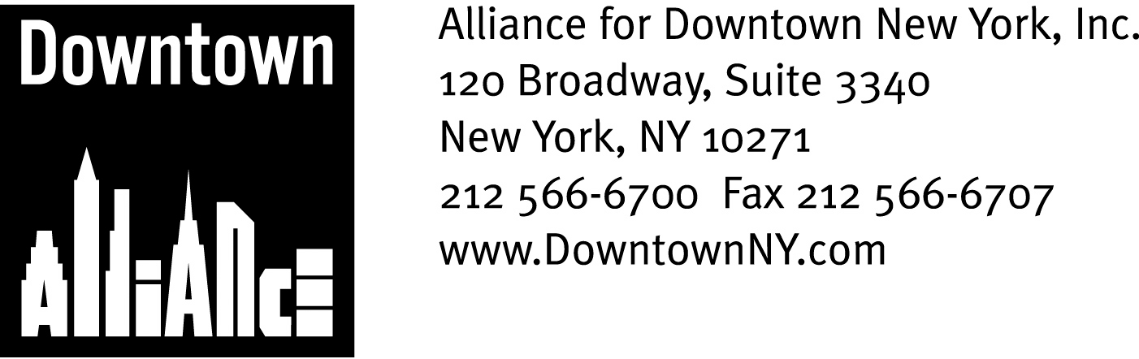

PRESS CONTACTS: Downtown Alliance, Bruce Brodoff (212-835-2770)
Shea Communications, George Shea, Mark Faris (212) 627-5766

FOR IMMEDIATE RELEASE

ALLIANCE FOR DOWNTOWN NEW YORK SUPPORTS STATE SENATOR SQUADRON’S UNLAWFUL VENDING LEGISLATION
Proposed Bill Will Add Teeth to Enforcement of Existing Laws and Make Lower Manhattan’s Narrow Streets Safe for Pedestrians and Lawful Vending
New York, NY, April 23, 2009 —
The Alliance for Downtown New York, the Lower Manhattan Business Improvement District, applauds State Senator Squadron’s proposal to make unlawful vending a finger-printable offense. This bill is a critical tool in the fight to maintain safe, navigable and attractive streets in Lower Manhattan and New York City.
Senator Squadron’s bill would allow the police to fingerprint all unlicensed vendors and licensed vendors who violate the law, giving enforcement authorities the ability to track repeat offenders. The results would be dramatic on Lower Manhattan’s narrow, crowded streets and the sidewalks surrounding the World Trade Center site, which were declared no-vending zones by the New York State Legislature in 2004.
“While lawful vending is an important New York City tradition, there is simply no room for unlawful vending activity in Lower Manhattan,” said Elizabeth H. Berger, President of the Alliance for Downtown New York. “Unlawful vendors create unsafe conditions throughout our district, and especially around the World Trade Center site. Now is the time to start enforcing the laws that are already on the books, and I applaud State Senator Squadron for introducing legislation that will allow lawful vendors to operate, safeguard pedestrians, honor the World Trade Center site and maintain the economic competitiveness of Lower Manhattan.”
Curbing unlawful vending in Lower Manhattan has long been a priority for the Downtown Alliance. The district’s pre-Revolutionary Period street grid was not designed for today’s pedestrian and vehicular traffic, and regular street closings due to post 9/11 security and construction activities has made getting around the district more challenging. The proliferation of unlawful vendors on these already crowded streets has created unsafe conditions, frustration and threatens tenant and investor confidence in Lower Manhattan.
-more-

Unlawful Vending
Page 2
It doesn’t have to be this way. Existing laws already establish criteria for lawful vending; What is needed is a comprehensive, multi-agency plan to remedy this city-wide problem.

In October 2008, the Downtown Alliance produced a draft report concerning unlawful vending that recommends a Seven-Point Action Plan. This plan identifies education, strengthening enforcement and stronger and clearer legislation as the most critical tools in the fight to eliminate unlawful vending.
The Downtown Alliance believes that clear and simple explication of existing vending laws among vendors, city agencies, law enforcement and the public, coupled with consistent and coordinated enforcement – including the creation of a dedicated Lower Manhattan vending taskforce and police foot patrols – are the only way to solve this well-entrenched problem.

We applaud the enforcement efforts of the New York City Police Department, The Port Authority Police Department and the work of our elected and appointed leaders including Mayor Bloomberg, Assembly Speaker Silver, Manhattan Borough President Scott Stringer, Councilman Alan Gerson, Port Authority Executive Director Chris Ward and Community Board 1, but there is more to be done. Senator Squadron’s proposal to make unlawful vending a finger-printable offense is a major step in finally achieving this goal.
“Right now, getting caught is simply the cost of doing business for illegal vendors,” said Senator Squadron. “If unlicensed vendors present false identification when they get caught, they can slip away again and again. Even when they do pay, there's not enough incentive for them to stop. Meanwhile, pedestrians, the community and businesses, including lawful vendors, suffer. We need to give the police new tools to crack down on illegal vending. I appreciate the work the Downtown Alliance has done on this issue and the support they are giving this bill, and I look forward to working with them to ensure the safety, attractiveness and economic viability of our community.”
- ### -

