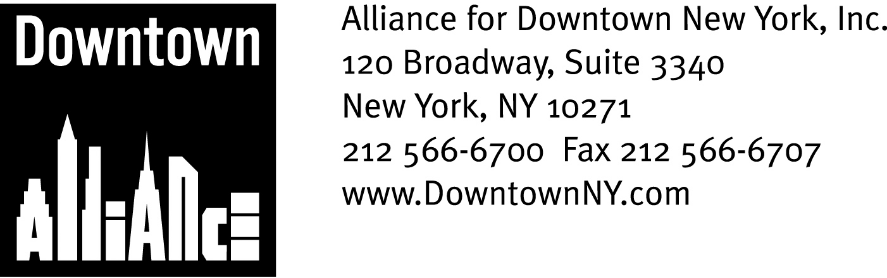

PRESS CONTACTS: Downtown Alliance, Bruce Brodoff 212-835-2770
Shea Communications, George Shea, Mark Faris (212) 627-5766

FOR IMMEDIATE RELEASE

STATEMENT OF
THE ALLIANCE FOR DOWNTOWN NEW YORK
ON UNLAWFUL VENDING IN LOWER MANHATTAN

Enforcement of Existing Vending Laws Is A Top Priority, says President Elizabeth H. Berger; Unlawful Vending Threatens Public Safety and Economic Vitality in Lower Manhattan

New York, November 14, 2008 —
Good morning Chairman Comrie and Chairman Stewart
I am Liz Berger, President of the Alliance for Downtown New York, and I am here this morning to let you know how important it is to enforce existing vending laws and regulations as you consider legislative action.

While modifying the city-wide licensing and regulatory structure, as our own Council Member Alan Gerson and also the BID managers Association, of which I am a member, have proposed, is important, existing conditions in Lower Manhattan are such that we cannot wait for a legislative solution. Lawful vendors deserve the opportunity to operate safely and successfully. Pedestrians deserve navigable and welcoming streets and sidewalks. Both are hard to achieve in post-9/11 Lower Manhattan, but I believe that clear and simple explication of existing vending laws, coupled with consistent and coordinated enforcement, will make a big difference in the safety, attractiveness and economic competitiveness of our community.

As Borough President Stringer has suggested, let’s start with the perimeter of the World Trade Center site. In 2004, the State Legislature, led by our own Assemblyman, Sheldon Silver, passed legislation prohibiting street vending of any kind around the World Trade Center site. Under City, State and federal case law, street vending is permitted on many Downtown sidewalks, but not around this hallowed ground and intensely busy construction site, period.

My great-grandfather was an immigrant peddler, and I strongly believe that street vending is a time honored New York City tradition; Lower Manhattan wouldn’t be part of Gotham without it! Lawful vending provides our workers, residents and visitors with inexpensive dining and shopping alternatives, and entry-level entrepreneurs with a way to earn a living. Since 9/11, our one square mile of 400 year-old narrow and winding streets have been closed for security reasons or obstructed by construction. Sidewalk and street congestion is at a breakpoint, and projected to get worse. Add to that the 318,000 workers, almost 57,000 residents and nearly 6 million annual visitors to Lower Manhattan.

In this context, we can no longer afford unlawful street vending to block streets, sidewalks and building entrances and exits. We cannot permit unlawful vending at prohibited times, in prohibited spaces and prohibited ways.

While imperfect, existing laws and regulations are designed to safeguard pedestrians while allowing street vendors to sell their wares. Seven City agencies, and, in some parts of Lower Manhattan, the Port Authority, have jurisdiction over licensure (or concessioning) as well as where, when and how street vendors may operate. This much is clear: State and City statute and federal case law spell out in specific detail what constitutes lawful and unlawful vending.

It’s time to respect and enforce these rules in Lower Manhattan and, of course, throughout New York City. Thank you.

-- ### --

The mission of the Alliance for Downtown New York is to be the principal organization that provides Lower Manhattan's historic financial district with a premier physical and economic environment, advocates for businesses and property owners and promotes the area as a world-class destination for companies, workers, residents and visitors. The Downtown Alliance manages the Downtown-Lower Manhattan Business Improvement District (BID), serving an area roughly from City Hall to the Battery, from the East River to West Street.

