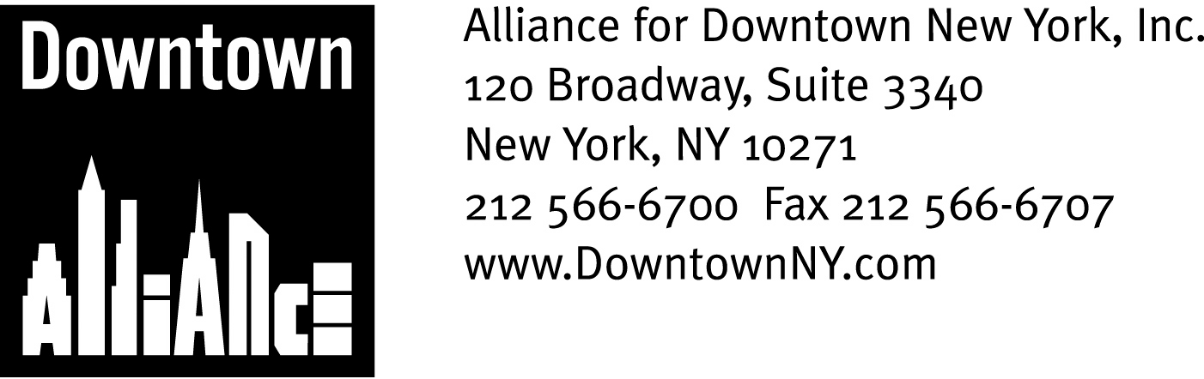

PRESS CONTACTS: Downtown Alliance, Bruce Brodoff 212-835-2770
Shea Communications, George Shea, Mark Faris (212) 627-5766

FOR IMMEDIATE RELEASE

TESTIMONY OF THE ALLIANCE FOR DOWNTOWN NEW YORK REGARDING CONSTRUCTION PROGRESS AT THE WORLD TRADE CENTER SITE AND THE FULTON TRANSIT CENTER

The Port Authority Must Stick to the Current World Trade Center Schedule, says President Elizabeth H. Berger, and the MTA Must Finish the Fulton Transit Center Without Further Delays; Both Projects Are Critical to Keeping Lower Manhattan and New York City a World Financial Capital and Competitive in the Global Marketplace

New York, January 29, 2009 –

Good afternoon Speaker Silver, Chairperson Brennan, Chairperson Brodsky and Chairperson Millman.

I am Elizabeth H. Berger, president of the Alliance for Downtown New York, the business improvement district representing Lower Manhattan, the nation’s oldest and fourth largest central business district.

Thank you, Mr. Speaker, for all you have done to help Lower Manhattan recover and rebound from the attacks of 9/11.
I am going to start with the bottom line: Lower Manhattan’s future as an international business district begins with rebuilding the World Trade Center site and related post-9/11 projects like the Fulton Transit Center, which you have championed. This is as true in today’s economic climate as it ever was, perhaps more so, and, to quote our new President, they are “shovel-ready.”
And, they’re not just about Downtown. There is no better way for New York to create immediate jobs and bolster our entire region’s long-term competitiveness. Port Authority Executive Director Chris Ward’s new road map for rebuilding the site has provided an excellent way to get going. Chris Ward gets it, and his frank and honest assessment of what it takes is a breath of fresh air. Chris also gets that it’s a long way from here to there, and his attention to street level conditions and the pedestrian experience around the site is welcome and long overdue.

But getting it right means more than meeting the new schedule. It means moving ahead with each critical element of the project as planned: the office towers, the retail, the performing arts center, through streets, the memorial and the museum. It means business and government fully committing to a collective vision of the next World Trade Center as a bustling and vibrant commercial destination.

And that’s the whole point: rebuilding the World Trade Center site and projects like the Fulton Transit Center are not about what happened but about what can happen in Lower Manhattan.

This year we are celebrating the Henry Hudson quadcentennial. For 400 years, Lower Manhattan has been a bellwether of what was once known as the New World, epitomized in what became New York City. There was no more powerful symbol of the totality of its ambition than the World Trade Center. A new World Trade Center must once again become the centerpiece of Lower Manhattan, a community that is now a global model for a 21st century business district. And, not a moment too soon.

Lower Manhattan is home to 318,000 employees and 57,000 residents, and last year hosted 6 million annual tourists. It has become a location of choice for all sectors. It must stay that way, and be ready for the next wave of investment and prosperity. That’s why these projects just can’t wait.

The Fulton Transit Center is a case in point. No part of New York City is more connected to the entire metropolitan area: 14 subway lines and 12 stations, 8 local and 25 express bus routes, multiple ferry routes, a heliport and PATH train service to New Jersey. Total transit ridership in 2007 was 123 million people. And here’s the thing: 90% of Lower Manhattan’s workers take mass transit or walk to work, and they, and the firms which employ them, are tired of waiting for transit amenities common in other global business capitals. They are tired of construction chaos and street closures, a degraded pedestrian experience, vast public expenditures with too few visible signs of progress and being told to manage their expectations.

What are we waiting for? A rebuilt World Trade Center and an above-ground, architecturally significant Fulton Transit Center with significant retail are what Lower Manhattan needs, what Lower Manhattan was promised and what Lower Manhattan deserves.

Thank you for your support and confidence in the future of Lower Manhattan.

###

