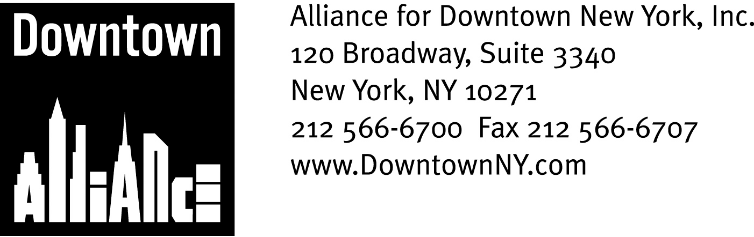

PRESS CONTACTS: Downtown Alliance, Bruce Brodoff (212) 835-2770
Shea Communications, George Shea, Mark Faris (212) 627-5766

FOR IMMEDIATE RELEASE

LOWER MANHATTAN NAMED ONE OF AMERICA’S
MOST WALKABLE NEIGHBORHOODS

Compact Size, Accessibility, Growing Commercial, Residential & Retail Sectors,
Green Initiatives Make District a Global Model for 24/7 Live/Work Community
______________________________________________________________________

New York, NY, September 8, 2008 – Lower Manhattan has been named one of America’s most walkable neighborhoods by Walk Score, a Web site geared to helping potential homebuyers or renters discover if their potential new neighborhood ranks as pedestrian-friendly. Walk Score’s new list is the first objective national ranking of “walkability,” with findings based on analysis of 2,508 neighborhoods in the 40 most populous U.S. cities.

New York City ranked second on the national list just behind San Francisco with a “walk score” of 86 out of 100. Among all of New York’s neighborhoods, the Financial District – the heart of Lower Manhattan – achieved a walk score of 99, earning it a “Walker’s Paradise” designation for achieving a walk score of 90 or greater.

“Lower Manhattan’s near-perfect ranking on the Walk Score survey is further confirmation that Lower Manhattan is a scalable community on a human scale and a global model for a 21st century, 24/7 live/work community,” said Elizabeth H. Berger, president of the Alliance for Downtown New York and a long-time Lower Manhattan resident who walks to work. “Lower Manhattan is the nation’s fourth-largest central business district, and the area packs an astonishing array of quality-of-life attributes into its one square mile. A wide variety of housing options, an unmatched public transportation network, great schools, great restaurants, great shopping and services, historical sites that define our nation, first-class museums and the most beautiful harbor and open spaces in the world are all within a ten-minute walk, making Lower Manhattan one of the nation’s best places to work, live, visit and lace up your walking shoes!”

Lower Manhattan’s thriving business environment, desirable quality of life and “car-lite lifestyle” account for the tremendous growth of the district’s business and residential communities during the past six years. More than 312,000 people are employed by a wide variety of public service, non-profit and business entities, with 205 firms relocating from midtown Manhattan and other parts of the metropolitan area since 2005. These firms have leased more than 4.5 million square feet of office space, enjoying Lower Manhattan’s attractive commercial real estate offerings, value proposition and access to public transportation.
– more –

Lower Manhattan Walkability
Page 2

Lower Manhattan’s diversified economy and its walk-to-work way of life have helped drive residential growth to historic levels. Approximately 24,320 residential units currently exist in 294 buildings south of Chambers Street, bringing Lower Manhattan’s population to an estimated 48,600 people. Downtown New York may see a record-breaking year in 2008 for residential development, with a total of 4,415 units in 26 buildings scheduled to open before December. This new inventory will bring Lower Manhattan’s population to an estimated 57,200 by year-end 2008, an 18 percent increase over 2007 and nearly three times its 2001 population.
An exciting array of retailers, restaurants and other businesses are now capitalizing on Lower Manhattan’s steady growth, opening new stores and providing new services to the district’s rapidly expanding number of employees and residents.
Lower Manhattan’s walkability factor is also a major contributor to the district’s position at the forefront of New York City’s green revolution. With nearly 16 million square-feet of LEED-certified space in the pipeline and the aforementioned unparalleled mass transit access and walk-to-work community, Lower Manhattan is fast becoming New York City’s greenest neighborhood. The Alliance for Downtown New York, through its “Going Green Downtown initiative and free bike-sharing program, is playing a large role in building a sustainable Lower Manhattan.
For detailed information on Lower Manhattan’s business and residential communities, retailers, restaurants, attractions, green initiatives and the Downtown Alliance’s free walking tours of the Financial District, please visit www.downtownny.com
The mission of the Alliance for Downtown New York is to be the principal organization that provides Lower Manhattan's historic financial district with a premier physical and economic environment, advocates for businesses and property owners and promotes the area as a world-class destination for companies, workers, residents and visitors. The Downtown Alliance manages the Downtown-Lower Manhattan Business Improvement District (BID), serving an area roughly from City Hall to the Battery, from the East River to West Street.

###

