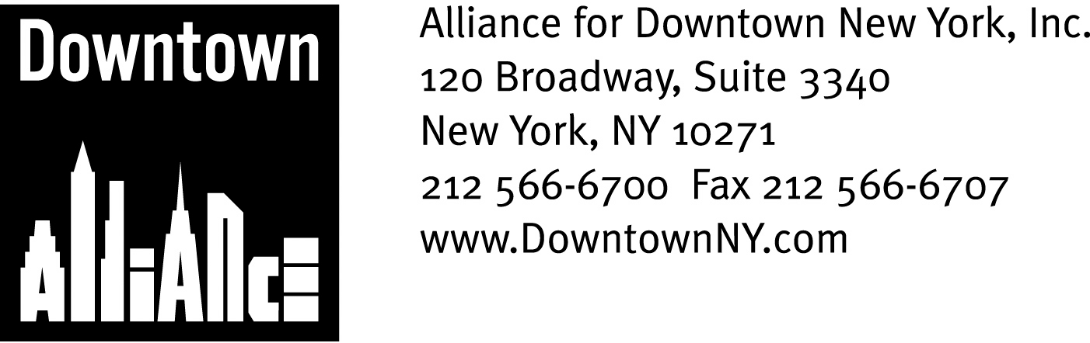

PRESS CONTACTS: Downtown Alliance, Bruce Brodoff (212) 835-2770
Shea Communications, George Shea, Mark Faris (212) 627-5766

Downtown Alliance Launches
Initiative to Support Lower Manhattan Retailers and Attract Additional Retail Investment

Lower Manhattan is one of the most dynamic and successful live-work communities in the world, a fast-growing, 24/7 district whose combination of diversified industry, in-demand housing options and world-class attractions in one walkable square mile has attracted more than 100 new retailers and eateries since 2002. The Alliance for Downtown New York is stoking this momentum by launching an investor and consumer-focused multi-media marketing initiative, including a “Lower Manhattan Retail Lounge” at the upcoming ICSC conference, that highlights Lower Manhattan’s exciting roster of retailers and restaurants, positions the neighborhood as a premiere holiday shopping destination and promotes the benefits of opening a business in New York City’s newest retail center.

This multiyear, “drive-to-web” marketing campaign is designed to support local retailers and attract new retailers and restaurants and includes print advertisements in a variety of publications including The New York Times, New York magazine, Time Out New York and The New York Observer and advertising posters prominently displayed at strategically selected bus shelters throughout Lower Manhattan, in all 13 PATH stations and on all PATH train lines. The campaign also includes a colorful “Downtown for the Holidays” brochure that features scores of Lower Manhattan retailers, a dedicated Web site (www.downtownny.com/shop) and e-blast promotions and mailers.

The campaign involves more than advertising; The Downtown Alliance will also link the promotion of its holiday shopping campaign with a variety of Lower Manhattan events, activities and venues, including the popular annual tree lighting ceremony and concert at Zuccotti Park and Seaport Ice, the brand-new outdoor rink at the South Street Seaport.

A crucial element of the marketing campaign is showing that Lower Manhattan is already a viable retail center with a critical mass of quality retailers and restaurant at every price point. Equally important is informing potential retailers that Lower Manhattan’s impressive and continued growth, coupled with its unmatched value proposition, offers an incredibly compelling opportunity for them to capitalize on a wealthy, worldly market seeking a greater range of products and services close to home and work.

Nearly 57,000 people – with an annual disposable income of approximately $3.3 billion – now live south of Chambers Street, and Lower Manhattan’s daily population of approximately 318,000 workers spend around $569 million in Lower Manhattan each year. In addition, the number of people who visit Lower Manhattan’s historic monuments, museums, waterfront and cultural events – about six million last year – is expected to increase to 10 million to 12 million following the completion of the World Trade Center Museum and Memorial.

As part of the Downtown Alliance’s efforts to encourage new retail tenancy and investment, the organization will celebrate the annual International Council of Shopping Centers conference in New York with a Lower Manhattan Retail Lounge at the Warwick Hotel on December 8, 9 and 10. Visitors to the lounge can learn more about New York’s most dynamic and exciting retail district and get an exclusive look at a dramatic scale model of Lower Manhattan and the new World Trade Center, courtesy of Silverstein Properties.

Registration at ICSC or any other RSVP is not required to visit the Lower Manhattan Retail Lounge. Please call 212-835-2799 for more information.

The tremendous growth of Lower Manhattan’s retail and dining sectors is directly related to the remarkable progress that the district has experienced over the past seven years. The Downtown Alliance will continue its efforts to highlight the area’s terrific shopping and dining opportunities that have helped transform Downtown New York into a true holiday and retail destination.

The mission of the Alliance for Downtown New York is to be the principal organization that provides Lower Manhattan's historic financial district with a premier physical and economic environment, advocates for businesses and property owners and promotes the area as a world-class destination for companies, workers, residents and visitors. The Downtown Alliance manages the Downtown-Lower Manhattan Business Improvement District (BID), serving an area roughly from City Hall to the Battery, from the East River to West Street.
###

